Herbert J. Dumas Sr.
April 18, 1934 – April 15, 2018

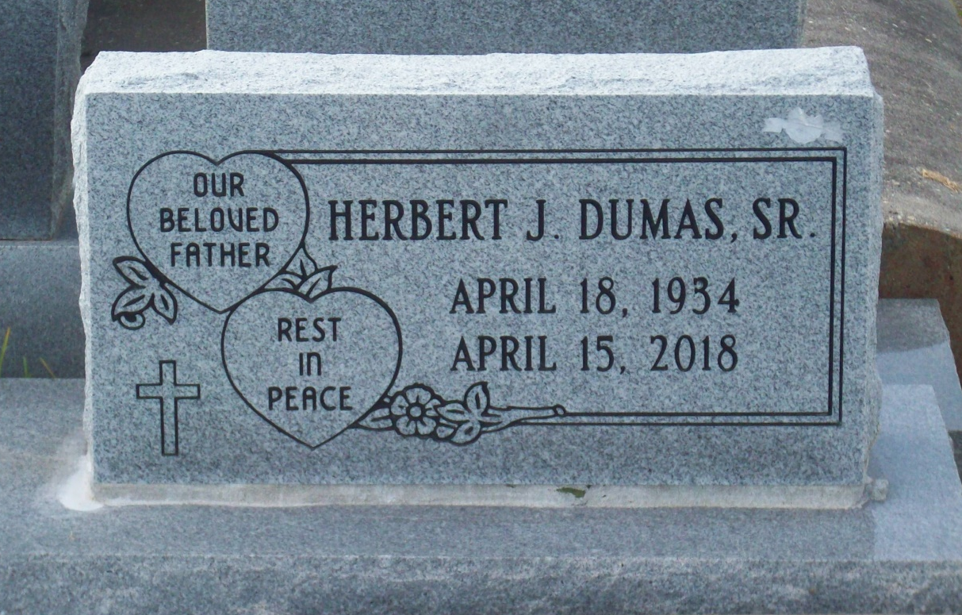
Photo by TMB

Herbert "Red", "P-Diddy" Dumas Sr. departed this life on Sunday, April 15, 2018, at his residence in Vacherie, LA. He was 83, a native and resident of Vacherie, LA. Survived by 3 sons, Herbert Dumas, Jr. (Lucretia), Dale Dumas (Michelle) and Michael Dumas (Brittany); 4 daughters, Theresa D. Isom (Terry, Sr.), Mary Melissa Dumas, Hope Dumas and Mary Elizabeth Dumas; 2 brothers, Sylvester Dumas and Joseph Dumas; 3 sisters, Anita D. Woods, Betty D. Paul and Floretta D. Harry; 15 grandchildren; 15 great-grandchildren; also a host of other relatives and friends. Preceded in death by his wife; Alice D. Dumas; parents, Floretta and Cyril Dumas; 2 sons, James Christopher Dumas and Gerald Dumas; 3 brothers, Eunice, Earnest and Roy Dumas.

Unknown source

