Ignatius Dumas
September 21, 1959 – October 23, 2016

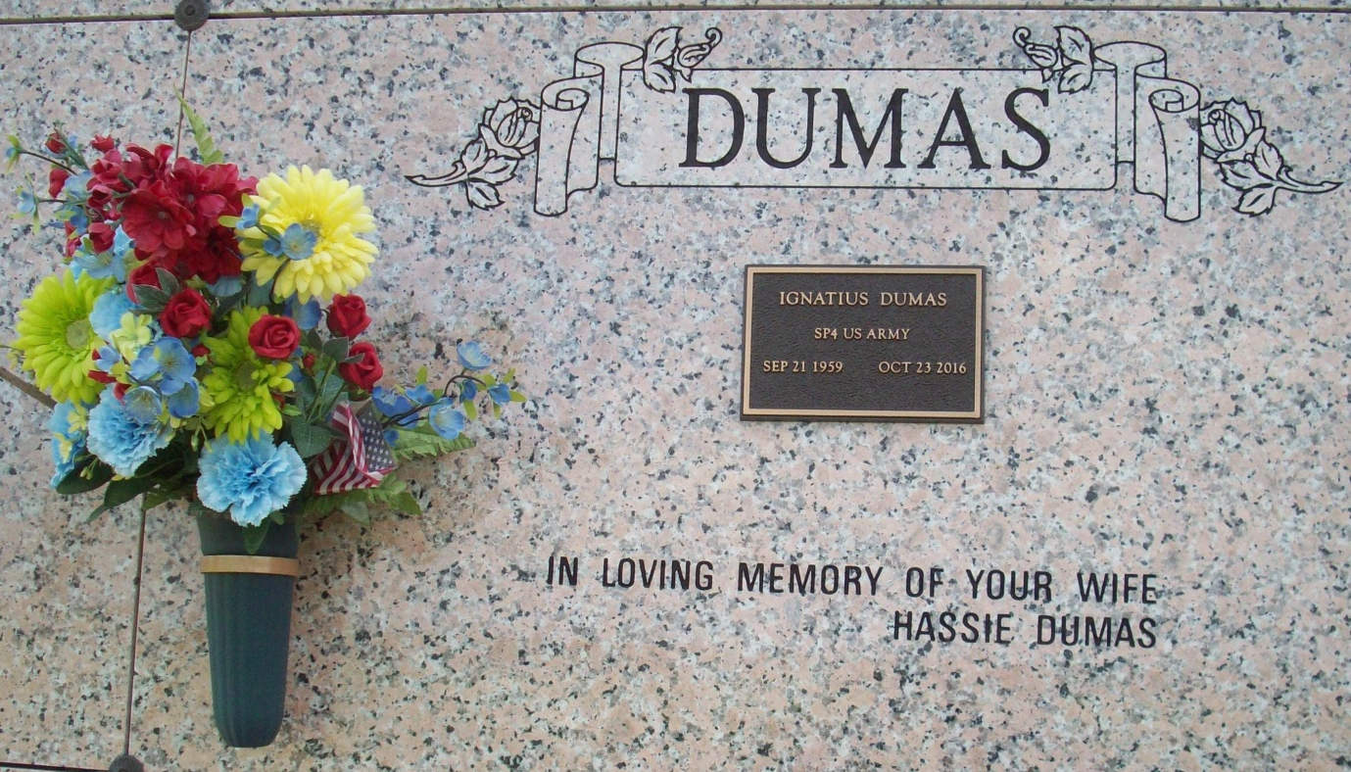
Photo by TMB

Ignatius Dumas, age 54, passed away on Sunday, October 23, 2016 at his place of residence. He was the husband of Hassie M. Dumas.
Ignatius served in the U.S. Army and was a Logistics Specialist with DRMO.
The family will receive friends at Our Lady of Peace Catholic Church in Vacherie, Louisiana on Wednesday, November 2, 2016 at 8:00 a.m. followed by Mass of Christian Burial at 11:00 a.m. Burial will follow in the church cemetery.
Arrangements by Williams & Southall Funeral Home, 5414 Hwy 1, Napoleonville, LA 985-369-7231. To sign guest book or offer condolences, visit our website at www.williamsandsouthallfuneralhome.com.

Houma Today, Terrebonne Parish, LA
Oct. 31 to Nov. 1, 2016

