Leo Paul Dumas
May 23, 1918 – November 19, 2008

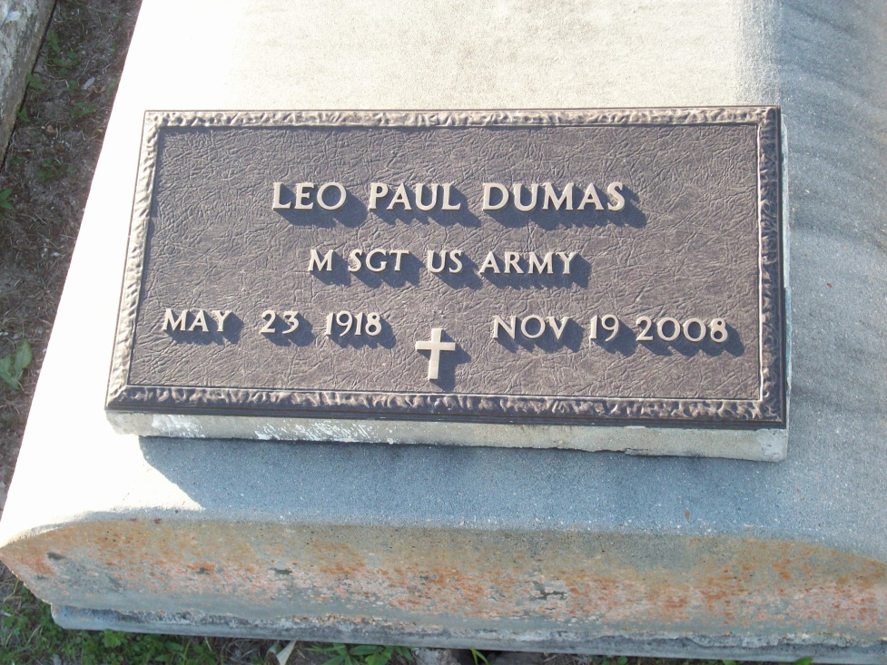
Photo by TMB

Leo Paul Dumas, 90, a native and resident of Vacherie, died Wednesday, Nov. 19, 2008 at Thibodaux Regional Medical Center in Thibodaux.He is survived by his son, Thaddeus Dumas; his wife, Brenda Dumas; two brothers, Russell and Anthony Dumas; two sisters, Mary Jane Freeman and Celeste James; five grandchildren; three great-grandchildren; and numerous nieces and nephews.
He was preceded in death by his parents, Paul and Rose Osborne Dumas; his first wife, Nelva O. Dumas; his second wife, Madelyn Schexnyder Dumas; four brothers, Harry, John, Hayward and Whitney Dumas Sr.; three sisters, Agnes Wooden, Victorine Simon and Wilborine Steib. A veteran of World War II and the Korean War, he retired as a master sergeant after a 26-year career in the U.S. Army. He was a member of American Legion Post 565 and served in the invasion of Normandy, France, during World War II.

Unknown source

