Leola (Armant) Dumas
March 25, 1931 – April 21, 2013

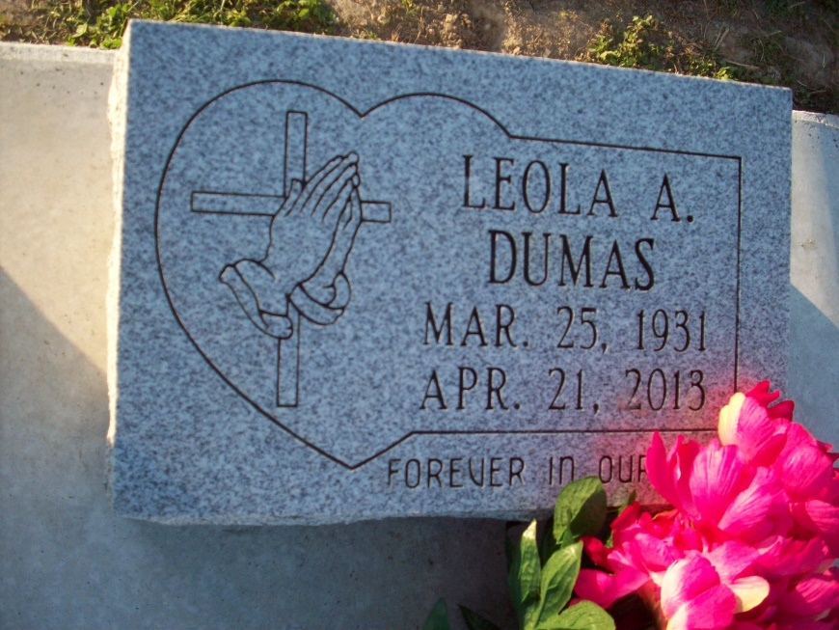
Photo by TMB

DUMAS Leola Armant Oubre Dumas, 82, of Vacherie, La., departed this life on Sunday, April 21, 2013. Beloved wife of the late Herman Dumas, Sr. Devoted mother of Paul Oubre, and the late Marie Oubre Lemieux. Step mother of 5 children. Daughter of the late Adolph and Francis Allen Armant. Sister of Morris (Grace) Armant and Charles (Delores) Armant. Also survived by a host of grandchildren, nieces, nephews, other relatives and friends.
Relatives and friends of the family are invited to attend the funeral services at Our Lady of Peace Catholic Church, 13281 Hwy 644, Vacherie, La. on Saturday, April 27, 2013, for 10:00 a.m. Pastor Michael Micelli, will be officiating. Visitation will be from 8:00 a.m. until time of service.
Interment will be at Our Lady of Peace Catholic Church Cemetery, Vacherie, La.
Funeral entrusted to The Baloney Funeral Home, Laplace, LA.
Published in The Times-Picayune (New Orleans, LA) from April 24 to April 26, 2013.

