Leona (Steib) Dumas
August 7, 1928 – July 27, 2013

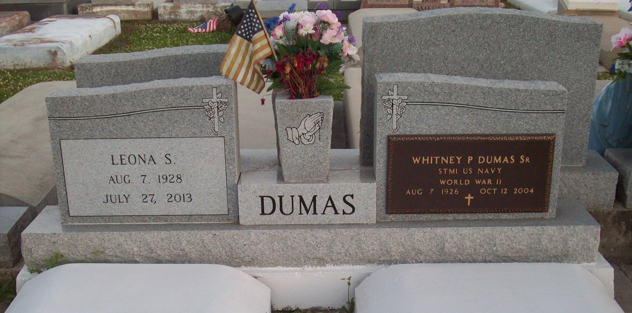
Photo by TMB

Leona Dumas, a homemaker, died Saturday, July 27, 2013 at her residence in Vacherie, La. She was 84 and a native of Vacherie. Survived by 6 sons, Nicholas, Whitney Jr., Harvey, Matthew, Timothy and Brian Dumas; 4 daughters, Mary Smith, Sally Wesley, Cynthia Himes and Aileen Ferchaud; 2 sisters, Lydia Keller and Olivia Joseph; 1 brother, Elroy Steib. Also survived by a host of other relatives and friends. Preceded in death by her husband, Whitney Dumas, Sr.; parents, Joseph and Josephia Steib Dumas; 1 brother, Paul Steib; 2 sisters, Beatrice Baptiste and Josephine Isom; and a daughter, Marie Rose Dumas. She was a member of the Knights of Peter Claver Ladies Auxiliary Court #161 and the Good Children Society.

Unknown obit

