Lovinia (Isom) Dumas
June 30, 1923 – May 14, 2004

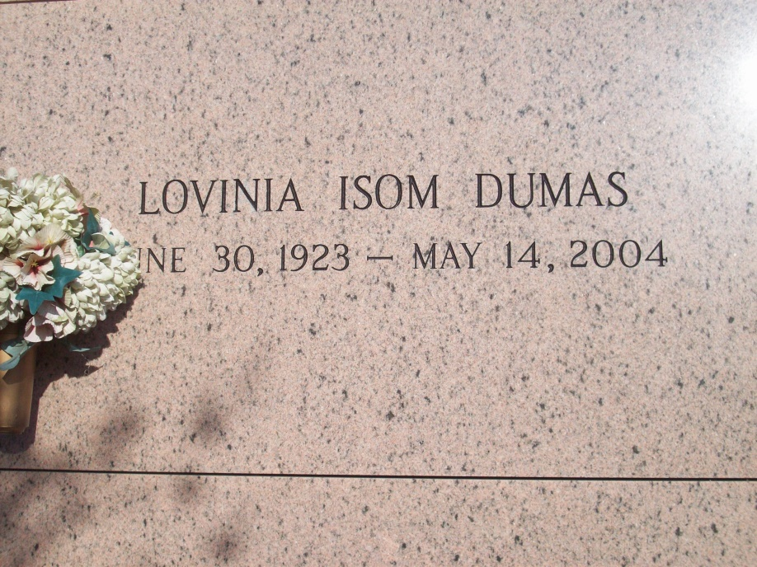
Photo by TMB

Lavinia (sic) Isom Dumas, a retired domestic worker, died Friday of liver cancer at her niece's home in Mount Airy. She was 80. Mrs. Dumas was born in Vacherie and lived in New Orleans. She was a member of the Altar Society at Our Lady of Lourdes Catholic Church and a member of the Good Children Society of Vacherie. Survivors include a son, Darrell Mark Dumas; two brothers, Joseph Henry Isom Sr. and Joseph Antoine Isom Sr.; a sister, Eloise I. Bartholomew; and two grandchildren. A Mass will be said Saturday at 10 a.m. at Our Lady of Peace Catholic Church, 13281 Highway 644, Vacherie. Visitation will be held Friday from 6 to 9 p.m. at Tharp-Sontheimer-Tharp Funeral Home, 4127 S. Claiborne Ave. Burial will be in the church mausoleum.

Times-Picayune, The (New Orleans, LA) - Thursday, May 20, 2004
Contributed by Jane Edson

