Lt. Colonel Marvin J. Dumas
February 21, 1960 – August 24, 2006

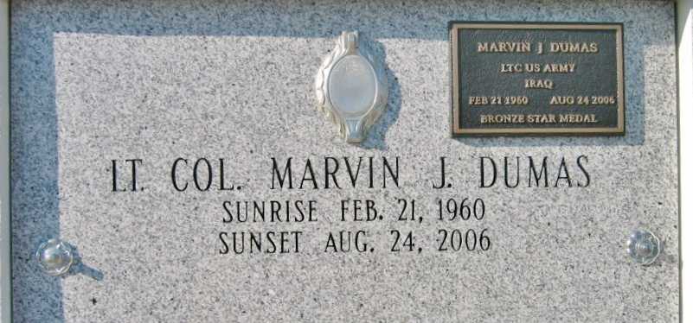
Photo by Bobby

Marvin John Dumas, Sr., age 46, passed away as a result of an automobile accident on Thursday, August 24, 2006 in Bellingham, WA. He was born on February 21, 1960 in Vacherie, Louisiana to Louis and Virginia (Steib) Dumas.
Marvin is survived by his spouse Cynthia (Gros), whom he married on May 28, 1982, two daughters Jerlyn Renee of Thibodaux, LA, Lia Alaina-Rose of Bellingham, WA, one son Marvin John Dumas, Jr. and one grand-daughter Anya Renee Dumas of Bellingham WA, parents Louis and Virginia (Steib) Dumas, two sisters Savona (Farrell) Joseph, Donna (Barry) Whittington, and three brothers Nathan Dumas, Louis Dumas, and Jonathan (Susan) Dumas.
Marvin was a Health and Safety Supervisor at Shell Puget Sound Refinery for 14 months. He previously worked for Shell Oil in Convent and Norco, Motiva LLC, Star Enterprises, Barbera Chevrolet, Equitable Insurance Company, and also played professional football with the New Orleans Saints and Baltimore Colts. He served in the U.S Army Reserves for 20 years with the 377 Theater Support Command and 469th Finance Group in New Orleans LA, where he received many awards. Marvin was very active volunteering with Boy Scout Troop 458 and Troop 373 while in Louisiana.
A Mass of Christian Burial will be celebrated at 11:00 am on Wednesday, August 30, 2006 at Our Lady of the Peace Catholic Church in Vacherie, LA, 13281 Hwy. 644, (225 265 3953) with burial in the church cemetery.
You may share your thoughts and memories of Marvin in the on-line memorial guest book at (www.nola.com/obits). In lieu of flowers, memorials may be made to Marvin J. Dumas Memorial Fund in care of Cynthia G. Dumas at First American Bank and Trust Account # 4053934. BALONEY FUNERAL HOME, LLC in charge.

The Times-Picayune, New Orleans, Louisiana
August 29, 2006

