Melvin Joseph Sr.
November 21, 1960 – July 27, 2017

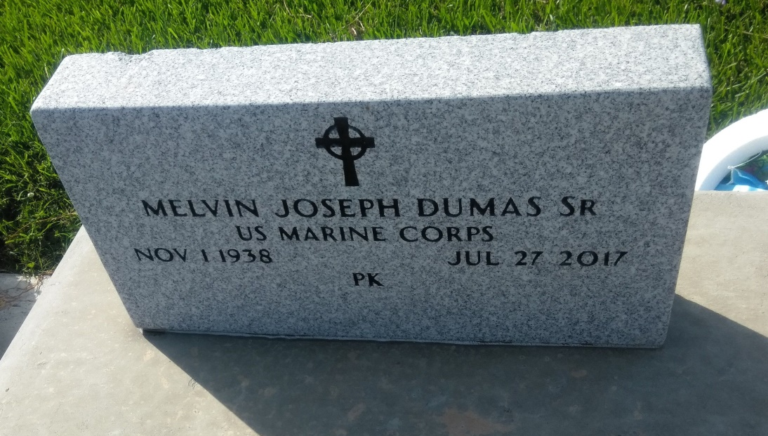
Photo by TMB

Melvin "PK" Dumas Sr., a native of Vacherie, LA passed away peacefully at his home on Thursday, July 27, 2017, at the age of 78. He received an Honorable Discharge from the United States Marine Corps in 1957. He retired from St. James Parish School System where he worked as a bus driver. He was the owner and operator of Dumas Enterprise Body & Glass and Dumas & Son's Wrecking Service. Melvin leaves to cherish his memories, his devoted primary care giver, wife Ruth Favorite Dumas; children Melvin Jr. (Debra), Zona (Alvin Jr.) both of Vacherie, LA., Alan (Bernadette) of Houston, TX, Nadine (Gregory) of New Orleans, LA, Kirk Sr. (Bernadine) of Thibodaux,LA, two sisters Mercidee Dumas Favorote (Joseph) and Julia Dumas Lindsay (Mose), both of New Orleans, LA; six brothers, Eliszy Jr.(Brenda) and Dave Dumas of Vacherie, LA.; Anthony and Michael (Mary) of Los Angeles, CA, Bertrand (Pam) and Martin Dumas Sr. (Troy) of New Orleans, LA. His grandchildren Delvin, Sr., Barrion Sr., Demel, Alanna, Alvin III, Kirk Jr., Gracian, Deja, Melvin & Meltrika. His great grandchildren Barrion Jr., Delvin Jr.and Autumn. He also leaves to cherish his memories his sisters-in-law, brothers-in-law, a host of neices, nephews, cousins, relatives and friends. Preceded in death by his parents Eliszy Sr.and Odile Dumas, one son Bruce, one sister Janice Dickerson.

Unknown source

