Odile D. Dumas
April 25, 1917 – July 5, 1999

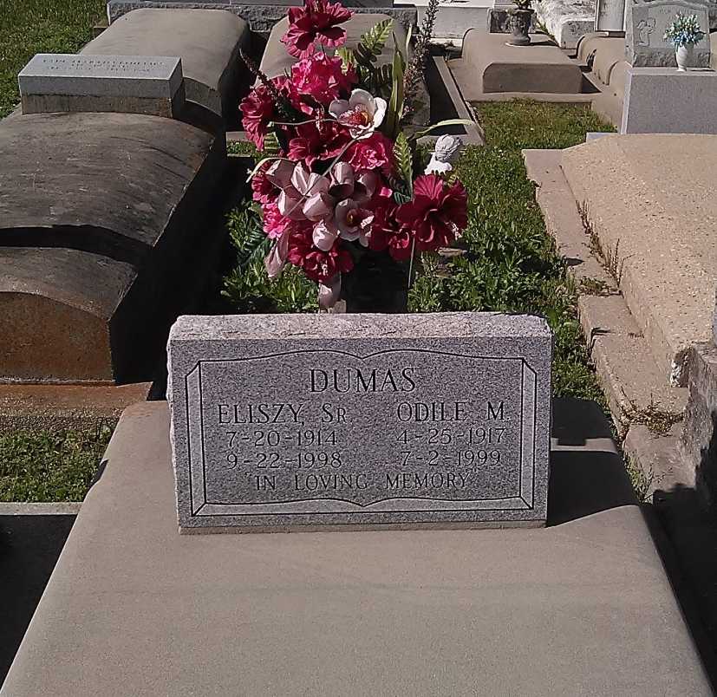
Photo by TMB

Odile D. Dumas, a homemaker, died July 2 at Memorial Medical Center. She was 82. Mrs. Dumas was a lifelong resident of Vacherie. She was a parishioner of Our Lady of Peace Catholic Church. She was a former member of Vacherie Social and Pleasure Club, Good Children Benevolent Association, the Knights of Peter Claver Lady's Auxiliary and the Altar Society. Survivors include seven sons, Dave, Michael and Anthony Dumas, all of Los Angeles, Bertrand Dumas Sr. and Dale Dumas Sr., both of New Orleans, Melvin Dumas Sr. and Eliszy Dumas Jr.; three daughters, Mercidee Favarote, Janice Dickerson and Julia Lindsay, all of New Orleans; two brothers, Eddie Dumas of New Orleans and Edwin Batiste of Los Angeles; 25 grandchildren; and 21 great-grandchildren.

Unknown obit

