Paul B. Dumas
July 19, 1890 – November 15, 1983

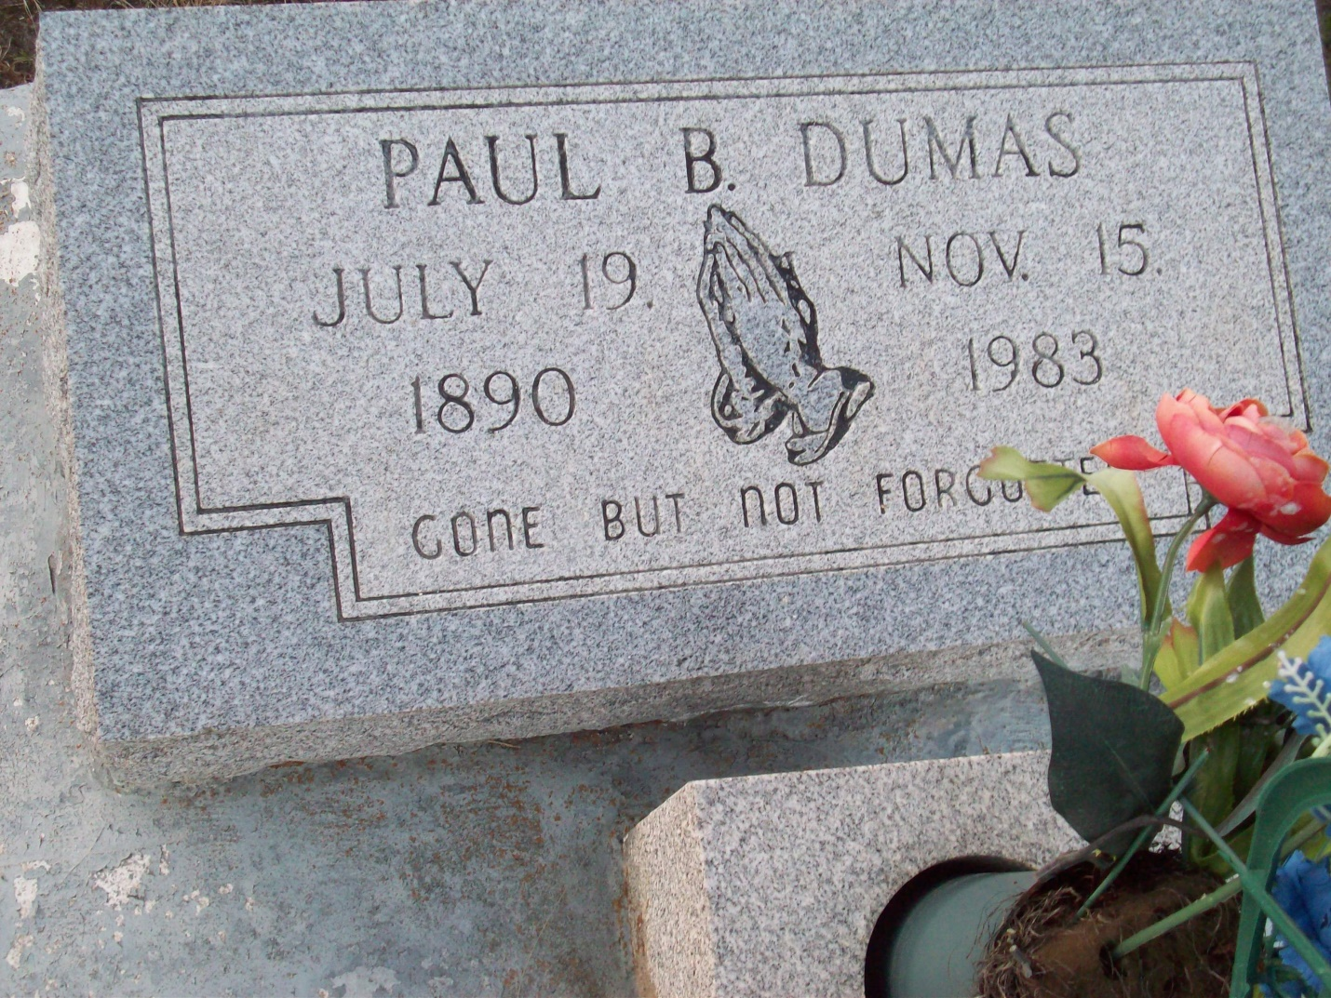
Photo by TMB

Paul B. Dumas, 93, died Tuesday, November 15, 1983. He was the husband of the late Rose Dumas; father of Wilberine Steib; Victorina Simon and Celeste James, all of Vacherie; Leo Dumas, California; Haywood Dumas, Marrero; Whitney, Harry and Anthony Dumas, all of Vacherie. He is survived by 66 grandchildren and 54 great-grandchildren.

Unknown obit

