Paul Joseph Dumas
September 7, 1936 – May 20, 2020

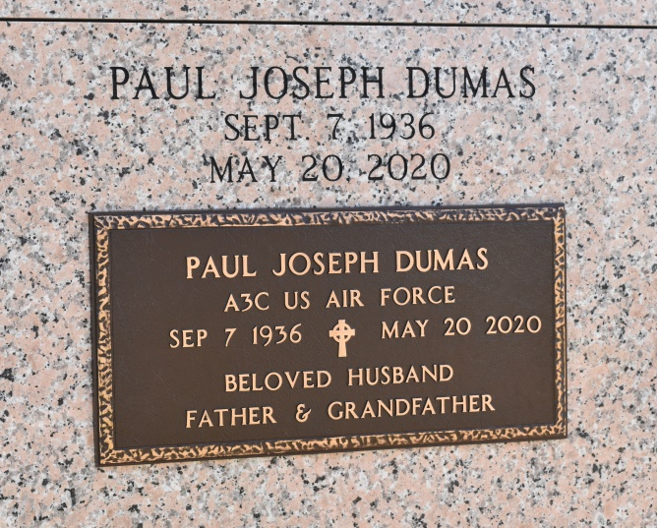

Paul Joseph Dumas was born in Vacherie, Louisiana to Gracieuse Jones and Pierre Eliszy Dumas on Labor Day, September 7, 1936, the youngest of 10 children. He entered eternal rest on Wednesday, May 20, 2020 at the age of 83. He was laid to rest Thursday, May 28, 2020 at Our Lady of Peace Catholic Cemetery and Mausoleum in Vacherie, Louisiana. He was preceded in death by his parents, Gracieuse Jones and Pierre Eliszy Dumas and siblings, the late Eastern Dumas, Sr., Eliszy Dumas, Sr., Herman Dumas, Sr., Grace Dumas Gros, Lucille Dumas Riley, Marie Elizabeth Dumas Harry, Gladys Dumas Trepagnier, Margaret Dumas Robinson, and Victor Dumas. Those left to cherish his memory are his wife, Mary Robert Dumas, children, Lorena (Bobby) Dumas-Guntner and Charmaine Lewis, grandchildren, Caitlyn Lewis and Cori Lewis, very special niece and nephew, Lelia (Herbert) McCullum and Kenny Johnson, sister-in-laws, Gracie Simon Dumas and Ruby Robert Johnson, and a host of nieces, nephews, other relatives and friends. Funeral services were entrusted to Murray Henderson Funeral Home.
The Times-Picayune, New Orleans, Louisiana
May 29 to May 31, 2020

