Russell M. Dumas
March 17, 1937 – September 12, 2016

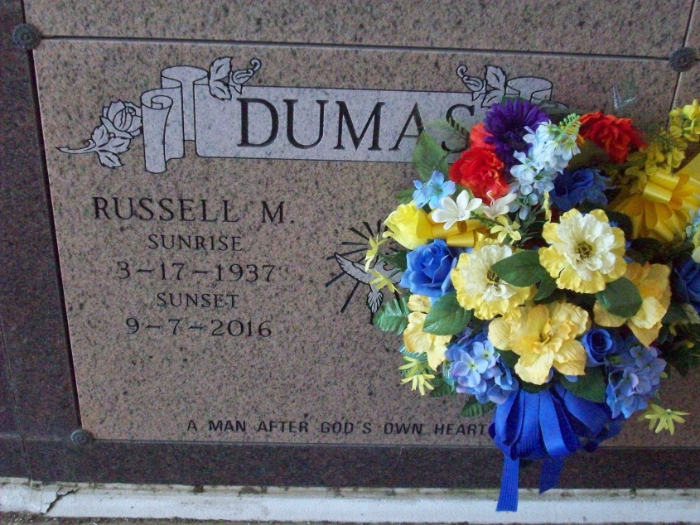
Photo by TMB

Russell "Russ" Dumas , 79, of Vacherie, LA accepted his wings from God on September 12, 2016. He was the son of the late Paul and Rose Dumas. He leaves to cherish his memories his wife, Rose Dumas; daughter, Dawn Dumas; son, Jonathan Dumas; he also reared Sandra Ingram ; 3 stepchildren, Catrice (Hosea) Stevens, Keisa (Eugene) and Kory Toussaint; 1 sister, Celeste James ; 2 brothers-in-law, Junious (Irene) Johnson, Paul (Iris) Johnson ; 3 sisters-in-law Delores and Joyce Dumas, Dolores Simmon; 7 grandchildren, Jonalyn, Zahilda, Jourdan, Raymond, Kimari, Kierra and De'Vante; 2 great-grandchildren, Loui and Lailyn and a host of neices, nephews, other relatives and friends who will truly miss him. Family and friends are invited to attend the Mass of Christian Burial on Monday, September 12, 2016 at Our Lady of Peace Catholic Church, Vacherie, LA. Visitation will begin at 8:30am followed by Mass of Christian Burial at 11am. Arrangements by Williams & Southall Funeral Home, 5414 Hwy 1, Napoleonville, LA (985) 369-7231. Interment Our Lady of Peace Catholic Church Cemetery.

Unknown source

