Sadie Marie (Laurent) Dumas
September 19, 1913 – April 20, 2005

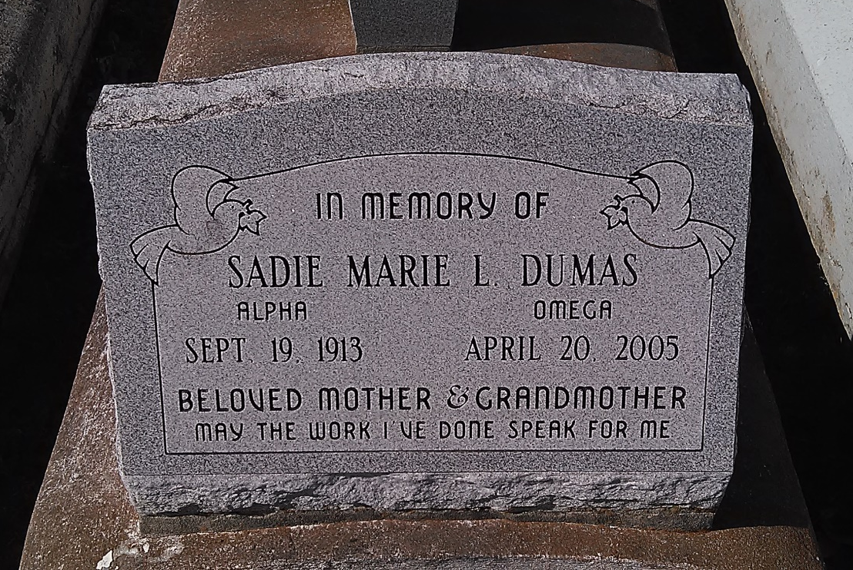
Photo by TMB

Sadie Marie Laurent Dumas (Maggie), Of Vacherie, La, On Wednesday, April 20, 2005, At Her Residence. Wife Of The Late Norbert Dumas, Sr. Daughter Of The Late Davis And Ora Lee Steib Laurent. Mother Of Felicia Dumas, Ida Carey, Henry C., Norbert Jr., Wesley Dumas And The Late Harold Sr., And Janetta Marie Washington. Sister Of Simeon And Nazie Laurent, And The Late George, Henry, Edward, Maurice, Joseph Laurent, Claudia Batiste, Rose Dumas, And Selena Ferguson. Mother-In-Law Of Lula Mae, Agnes And Sandra Dumas, Berlin Carey, And The Late Velma Wiltz Dumas And Henry Washington. Also Survived By (26) Grandchildren, (37) Great Grandchildren, (3) Great Great Grandchildren, Sisters And Brothers-In-Law, Nieces, Nephews, Cousins And Friends. Preceded In Death By (2) Great-Grandchildren. A Native And Resident Of Vacherie, La. Age 91 Years.

Unknown source

