Whitney P. Dumas
August 7, 1926 – October 12, 2004

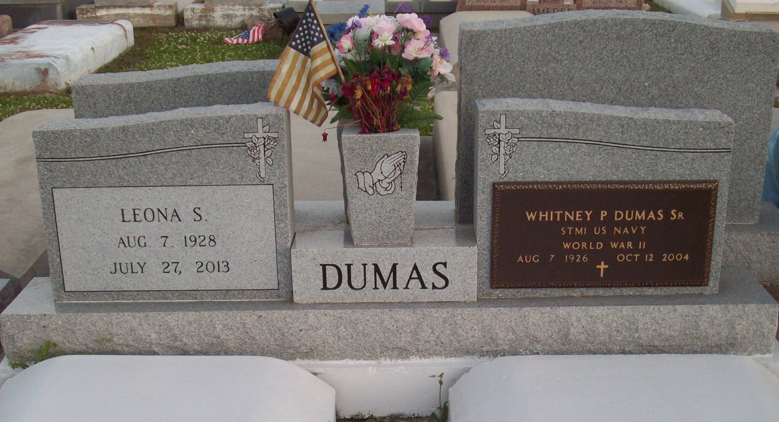
Photo by TMB

Whitney P. "Buckwheat" Dumas Sr., 78, a native and resident of Vacherie, died Oct. 12, 2004. He was the husband of Leona S. Dumas and father of Mary Smith, Sally Westley, Cynthia Himes, Alien Ferchaud, Nicholas, Whitney Jr., Harvey, Matthew, Timothy and Brian Dumas, and the late Marie Rose Dumas. He was also the son of the late Paul and Rose Dumas, and brother of Wilbourine Steib, Mary Freeman, Celeste James, Paul, Russell and Anthony Dumas, and the late Agnes Wooden, Victoria Simon, Harry, John and Haywood Dumas. He was a retired employee at Avondale Shipyards and also a member of the Good Children Society, American Legion Post 565 and Knights of Columbus Council 161.

Unknown source

