Charles J. Edgar Sr.
February 2, 1934 – December 4, 2015

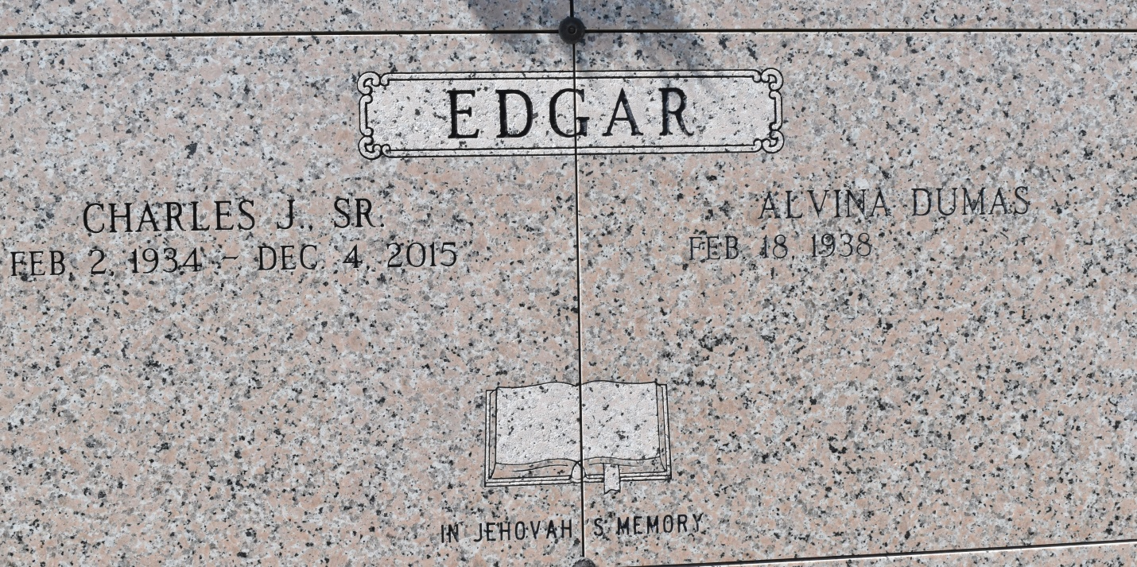

Charles Jackie “Jumpin Jack” “Boo Jack” Edgar Sr.
Passed away peacefully at the age of 81 on Dec. 4, 2015 at Thibodaux Regional Medical Center. A native of New Orleans, LA and a resident of Vacherie, LA. He dedicated his life to serve Jehovah and was baptized as one of Jehovah's Witnesses on June 7, 2014. Visitation will be held at the Kingdom Hall of Jehovah's Witness, 120 Hwy 3185, Thibodaux, LA on Saturday, Dec. 12, 2015 from 9:30am to Services at 11:30am. Funeral to begin 11:30am. Entombment in Our Lady of Peace Mausoleum in Vacherie, LA. Arrangements by Williams and Southall Funeral Home, 5414 Hwy 1, Napoleonville, LA (985) 369-7231. To sign guest book or offer condolences, visit our website at www.williamsandsouthallfuneralhome.com.
The Advocate, Baton Rouge, Louisiana
Dec. 10 to Dec. 12, 2015.

