Cecilia (Dumas) Esteen
November 26, 1927 – April 18, 2006

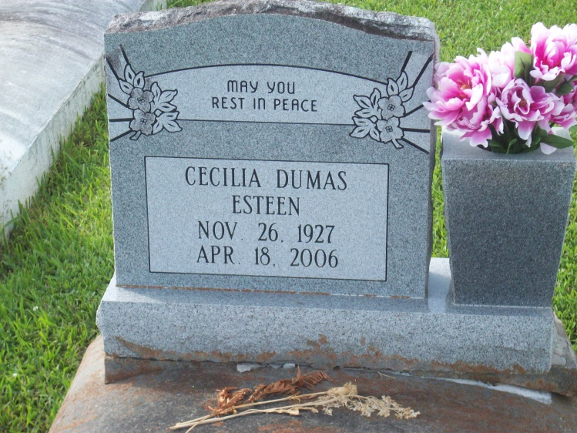
Photo by TMB

VACHERIE - Cecilia Dumas Esteen, 78, a native of Vacherie and a resident of New Orleans, died April 18. She was the wife of Lorenzo Esteen.
She is survived by her daughter Gertrude B. (Joseph Sr.) Robinson.
She is also survived by godchildren Joseph Jr. and Terrence Robinson, step-children Lorenzo Jr., Donald, Darrell, Wayne, Deanne and Debra Esteen, siblings Priscilla D. Gros, Velma D. Calloway, Helen D. Jeffery and Lois D. Batiste, as well as several step-grandchildren and great-grandchildren.
She was preceded in death by her parents Elphege and Eva Louis Dumas and siblings Essie D. Thornton, Maude D. Lemieux, Eva D. James, Ralph, Claude, Bernard, Eddie and Mildred Dumas.
Services were held April 21 at Our Lady of Peace Catholic Church, Vacherie, with interment in the church cemetery.

L'Observateur (La Place, LA) - Monday, April 24, 2006
Contributed by Jane Edson

