Preston Leonard Falgoust

August 29, 1933 – July 6, 2010

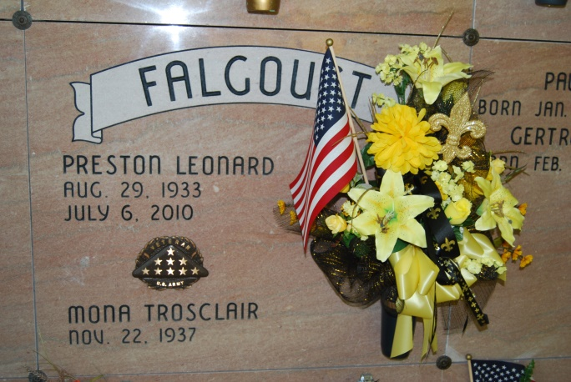

Photo by Kerry Keller

Preston Leonard Falgoust, 76, passed away Tuesday, July 6, 2010, at his home in St. James Parish. He was a retired sugar-cane farmer and an Army veteran of the Korean War, having served from 1953 to 1955. He was a retired member of First American Bank Board of Directors with 30 years service and former director of West St. James Parish Farm Bureau. Visitation at St. James Catholic Church, St. James, Thursday, July 8, from 8:30 a.m. until funeral service at 11 a.m. Christian burial at Our Lady of Peace Cemetery, Vacherie. Survived by his spouse, Mona Trosclair Falgoust; five children and their spouses, Vanessa F. and Robert Ayres, Nathan P. and Gwendolyn B. Falgoust, Wendell E. and Tammy O. Falgoust, Anna F. and Jerome Chauvin and Valerie F. and Mark Landry; 11 grandchildren, a stepgrandchild, two great-grandchildren, a stepgreat-grandchild; brothers, Herman Falgoust, and Lester and wife Myrna W. Falgoust; sisters, Gert Rousseau, and Ethel and husband Larry Martin. Preceded in death by his parents, Paul Nelson Falgoust and Gertrude Tregre Falgoust; sister-in-law, Eloise R. Falgoust; and brother-in-law, Roger Rousseau. In lieu of flowers, donations can be made to Ascension Catholic School or the American Lung Association of Louisiana. Condolences can be made on line at [www.oursodonaldsonville.com](http://www.oursodonaldsonville.com).

Advocate, The (Baton Rouge, LA) - Thursday, July 8, 2010

Contributed by Jane Edson