Larry Favorite

November 13, 1950 – September 1, 2007

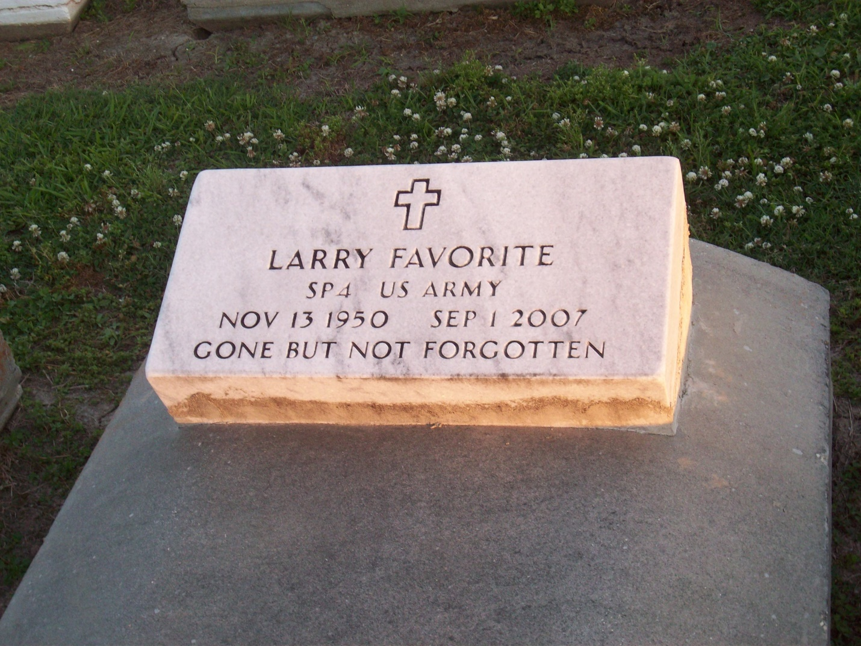

Photo by TMB

Larry Favorite, a 5 year Veteran and a retired deckhand at Beso Tugboat Company, departed this life on Saturday, September 1, 2007 at 10:40a.m. Father of Damon Banks, Lorenza Favorite, and Morris Favorite, III. Grandfather of Kiana Banks and Dymond Banks. Step grandfather of Cleanae' Crutchfield and India Marquez. Son of Lorenza Favorite and the late Morris Favorite, Sr. Brother of Clifton Favorite and Morris Favorite, Jr., Rose Wilson, Anniemae Favorite, Marion Favorite, Gail Perry, and Mercedes Lemieux. Father in law of Ingrid Banks. Brother in law of the late Norman Lemieux, Charles Perry, Fred Wilson, Jr., also survived by a host of nieces, nephews, cousins, other relatives and friends. Age 56 years, a native of Vacherie, La. and a resident of Harvey, La.

Unknown source