Lorenza (Melancon) Favorite

February 4, 1919 – January 3, 2008

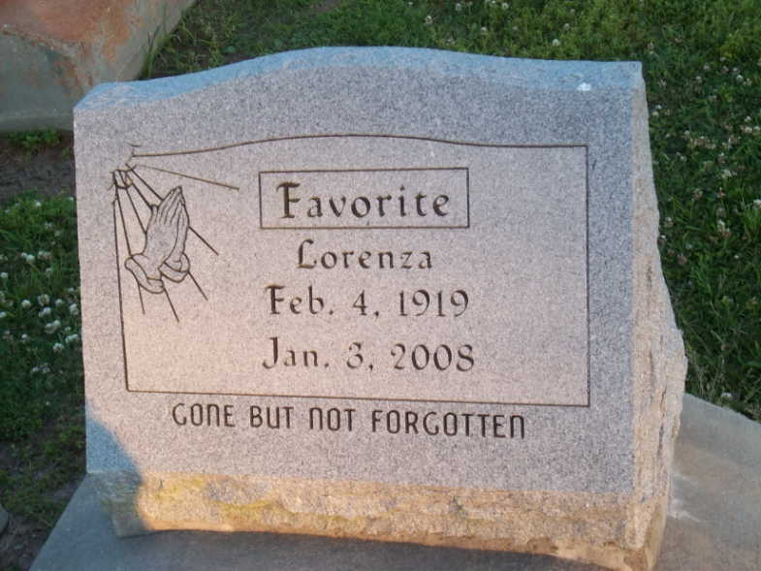

Photo by TMB

Lorenza Malone Favorite, Alpha February 4, 1919, Omega January 3, 2008.

God's loving angel, Lorenza Favorite was called home to glory on January 3, 2008. Lorenza is preceded in death by her caring husband, Morris Favorite, Sr.; her son Larry Favorite; mother and father, Lorenza and, Alexander Melancon; brothers, Joseph, Ferdinand and Alexander Melancon; Sisters, Emily and Rita Melancon; Son-in-laws, Charles Perry, Sr., Norman Lemieux and Fred Wilson, Jr. Lorenza is survived by her children Morris Favorite, Jr., Marion Favorite and her son Michael Favorite, Mercedes Lemieux, Annie Mae Favorite, Rose Wilson, Gail Perry and Clifton Favorite; her brother, Henry Melancon; her sisters, Eva Mae Hall and her Husband Lawrence Hall and Virginia Williams; also a host of grandchildren, great grandchildren, nieces, nephews and relatives.

Funeral services will be held at Holy Ghost Catholic Church, 2015 Louisiana Ave., New Orleans, LA 70115. Visitation is from 8:00 am to 10:00 am with services following. Her body will be laid to rest at Our Lady of Peace Cemetery, 13281 Highway 644, Vacherie, LA 70090.

Times-Picayune, New Orleans, LA

Jan. 11, 2008