Morris Favorite Sr.

March 4, 1913 – September 3, 1997

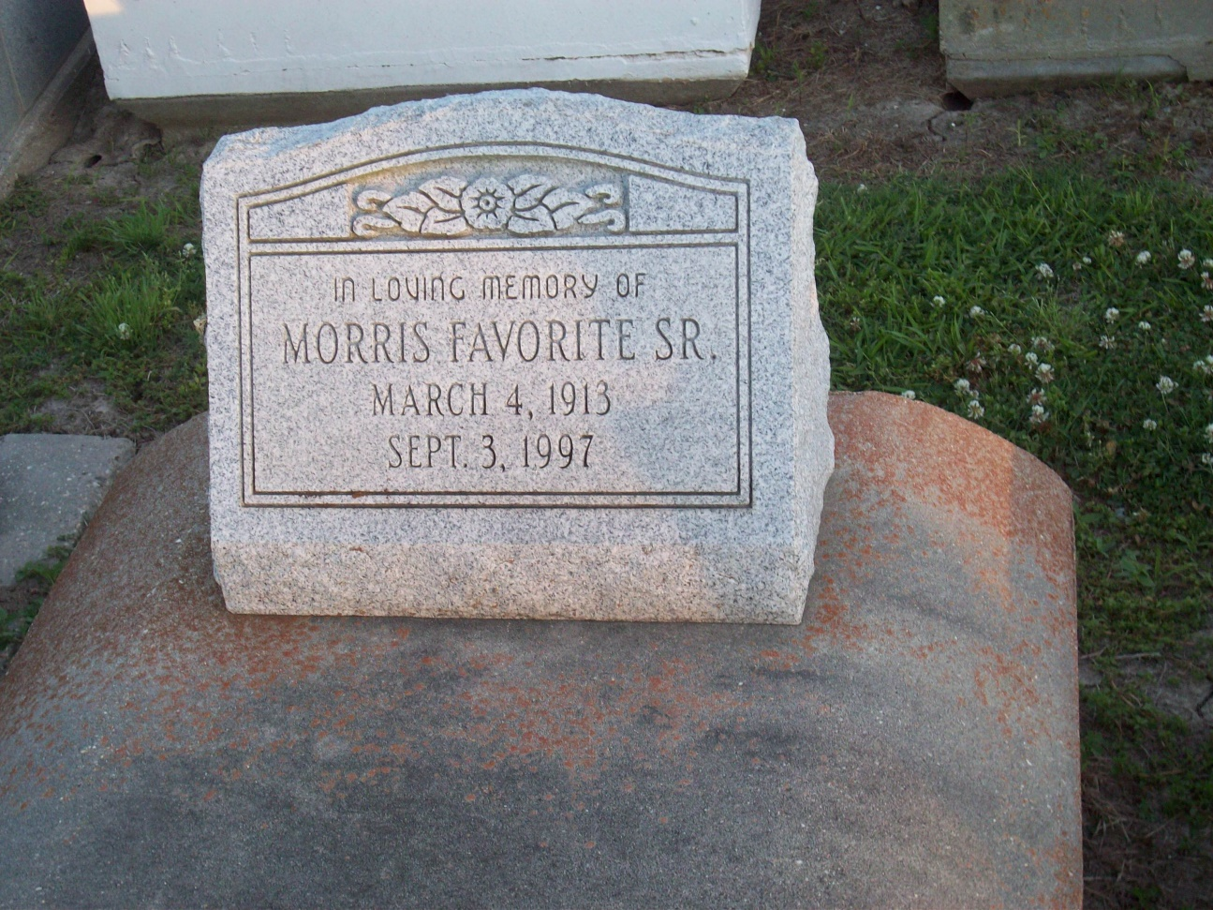

Photo by TMB

Maurice "Morris" Favorite, the owner of Morris and Son Landscaping, died Tuesday Sept 3, 1997 at Touro Infirmary. He was 84. Mr. Favorite was born in Vacherie and lived in New Orleans for the past 36 years. Survivors include his wife, Lorenza Favorite; three sons, Larry, Clifton and Maurice Favorite Jr.; five daughters, Mercedes Lemieux, Rose Wilson, Gail Perry, Marion and Annie Mae Favorite; five sisters, Lydia F. Dumas, Eldie F. Osborne, Marquite F. Travis, Edna Carmouche and Leona Favorite; a brother, Edmond Favorite; 24 grandchildren; and 17 great-grandchildren. A Mass will be said Monday at 10 a.m. at Holy Ghost Catholic Church, 2015 Louisiana Ave. Visitation will begin at 9 a.m. Burial will be in Our Lady of Peace Cemetery in Vacherie. D.W. Rhodes Funeral Home is in charge of arrangements.

Unknown source