Selina (Laurent) Ferguson

January 16, 1916 – June 18, 2004

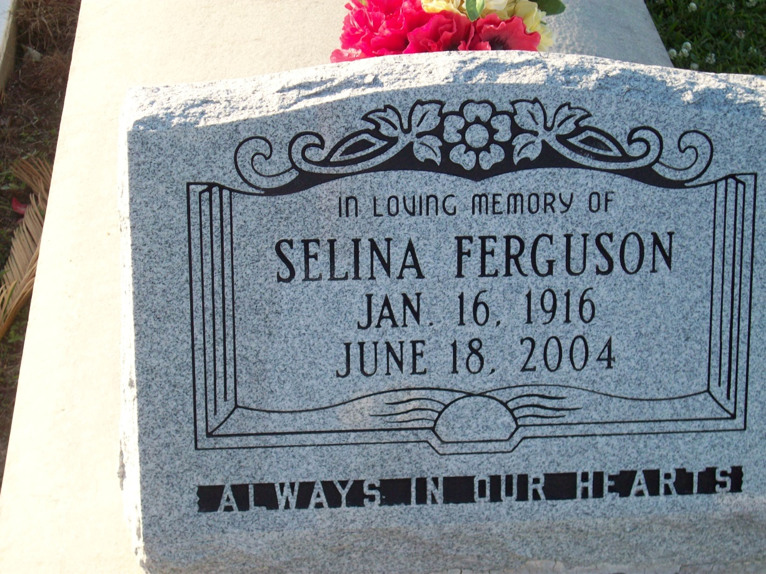

Photo by TMB

Selina L. Ferguson, On Friday, June 18 2004 At Canon Hospice, Jefferson, La. Daughter of The Late Aurlenia And Davis Laurent. Wife Of The Late Hosea Ferguson. Beloved Mother Of The Late Manuel Francois And Essie M. Scott. Sister Of Semion Laurent And Marie 'Maggie' Dumas, Preceded In Death By 2 Sisters And 5 Brothers. Also Survived By 3 Devoted Granddaughters, Angela Scott, Cynthia Melancon And Juanita Parquet That She Raised As Her Own, Numerous Grandchildren, Great Grandchildren, 1 Great Great Grandchild, And A Host Of Nieces, Nephews, Other Relatives And Friends. Age 88 Years. A Native On Vacherie, La And A Resident Of New Orleans, La.

Unknown source