Virgia (Becnel) Folse

December 8, 1942 – July 29, 2013

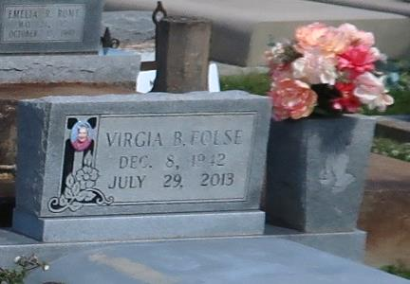

Virgia Becnel Folse, 70, a native and resident of Vacherie, died Monday, July 29, 2013.  
 Visitation will be from 9 a.m. until funeral time Friday at Our Lady of Peace Catholic Church. A Mass of Christian burial will be at 11 a.m. Friday at the church, with burial in Our Lady of Peace Cemetery.  
 She is survived by her son, Lester (Sherry) Folse Jr.; daughters, Sherry F. (Ken) Schexnayder and Carmela F. (Zebedee) Lasserre; companion, Septime "T-June" Rodrigue; son, Doug; sisters, Rose B. Gravois and Jeanne B. Gregoire; eight grandchildren; and two great-grandchildren.  
 She was preceded in death by her husband, Lester "Shine" Folse Sr.; parents, Louis Edward Becnel and Adele Stein Becnel; sister, Mariette B. Becnel; brothers, Elmo Becnel Sr. and Floyd Becnel Sr.; and companion, Robert "Bobby" Vedros.  
 Thibodaux Funeral Home is in charge of arrangements.

Houma Today, Terrebonne Parish, LA

Jul. 31 to Aug. 1, 2013.