Claire (Marse) Gauthreaux
July 20, 1929 - July 5, 2025

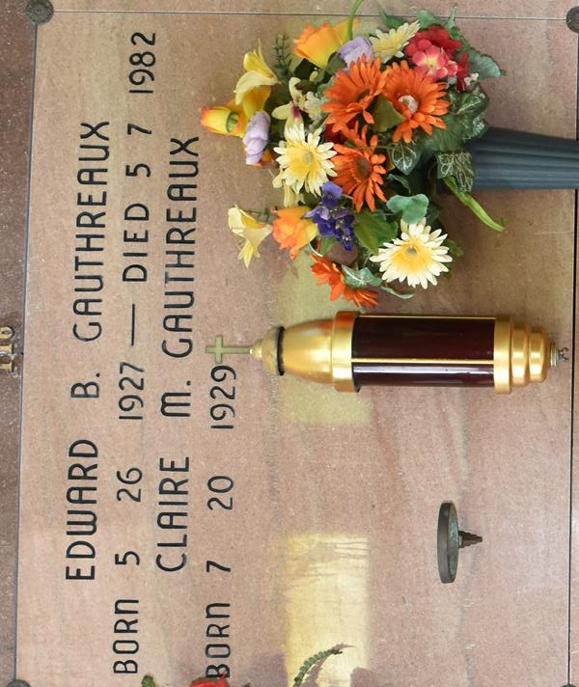

Claire “Peanut” Marse Gauthreaux a native and resident of Vacherie, born July 20, 1929 graced Heaven with her presence on July 5, 2025 at the age of 95.
Beloved wife of the late Edward “Ed” Gauthreaux. Loving mother of Michael Gauthreaux (Wanda), Mary Krohn (Rock), Kevin Gauthreaux (Martha), and the late Dale Gauthreaux. Grandmother of Donny Gauthreaux (Stephanie), Monique Bergeron, Angelle Tompkins (Michael), Andree Alleman (Ben), Eddie Gauthreaux (Camryn), Luke Gauthreaux, Brittany Rodriguez (Luis), Brooke Greenway (Richard), and the late Jay Ryan Gauthreaux, Casey Gauthreaux, Lance Bergeron, and Kirsten Krohn St. Pierre. Great-grandmother of 21 and one great-great grandchild. Daughter of the late Severas and Procla Falgout Marse and daughter-in-law of the late Alcide and Winnie LaCroix Gauthreaux. Sister of Augustine Hymel "Teen", the late Severas “June” Marse, Leonard “Chris” Marse, Augustin “Jean” Marse, Bernard “Ben” Marse, Bernadette Marse Tregre, and Rita Marse Delatte. Sister-in-law of the late Wilson “Bob” Gauthreaux, Arthur “Bay” Gauthreaux, Ambrose “Petch” Gauthreaux, Kermit “Boy” Gauthreaux (Annette), Myrtle Ann Gauthreaux, William Delatte, Kelsey Hymel, Alcide Tregre, and Dawn Marse. Also survived by numerous nieces, nephews, and godchildren.
Fondly known as Ms. Peanut, she was a devout Catholic who loved Jesus and could always be found with her rosary beads in her hands. Her undying faith brought her strength in the face of adversity, tragedy, and most of all much joy. She enjoyed life, was always singing and a smile on her face. “Maw Maw” loved all her grand kids, so much so they thought they were her favorite. One of the many things she was proud of and would try to beat quota each year was the amount of KC chicken dinners she would sell for Palm Sunday. Beat that quota she did and was recognized as an honorary Knights of Columbus member. She was quite a jokester and could make the best of a bad day. Her mottos were “Whatever will be, will be” and “Little Jesus doesn’t sleep”.
While working on the mail route, she would always find surprises for her, when opening a mailbox...fresh vegetables, hot meals, and cold drinks. As she got up in age, if you asked if she remembered you, she would say “Yes, you lived at such and such address”. She enjoyed watching her soaps, game shows, Hallmark movies, and the LSU Tigers. Ms. Peanut enjoyed her afternoon cups of coffee with family and friends. In 1984, she was awarded the distinct honor of being named Citizen of the Year in Vacherie. She was a member of the Catholic Daughters for 37 years and was named Catholic Daughter of the Year in 1988, and she served as a Eucharistic Minister. Her life’s work was being a “Mail Lady” for 28 years, which blessed her with many friends and “adopted” family. She was loved and admired by all who had the pleasure of knowing her. She will be deeply missed and always cherished.
The family would like to thank her caregivers who showed her great love as they would their own mother, Hope Hospice, Father Mike, Jeanne Adams, Susan Hotard. We would like to thank Suzanne Rome, Geralyn Becnel, and Teen Hymel for the cooked meals, sweet treats, and genuine care given to our mother.
Relatives and friends are invited to attend the Funeral Service at Our Lady of Peace Catholic Church, 13281 LA Hwy 644, Vacherie on Friday, July 11, 2025. Visitation will be held in church from 9:00 a.m. to 12:00 p.m. with the Funeral Mass to immediately follow at 12:00 p.m. Interment in Our Lady of Peace Cemetery.

Rose Lynn Funeral Home, Lutcher, Louisiana
July 9, 2025

