Marie Caroline (Steib) Gautier

April 7, 1944 – August 22, 2004

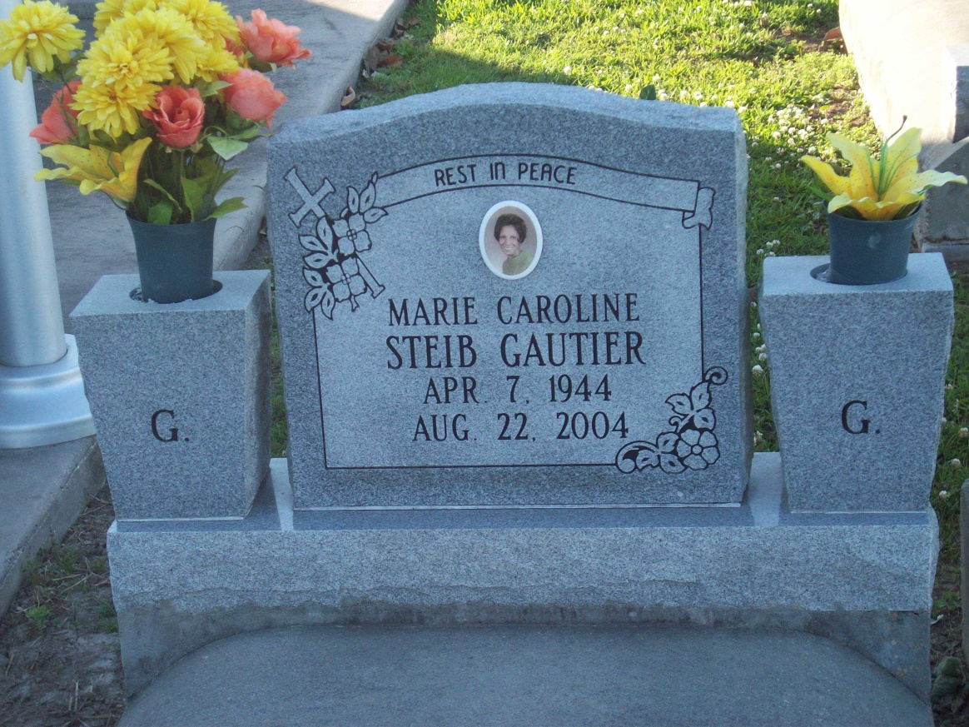

Photo by TMB

Marie Caroline Steib Gautier, a retired residential training specialist, died Aug. 22 of cancer at Ochsner Hospital. She was 60. Mrs. Gautier was born in Vacherie and lived in Jefferson. She was a substitute teacher for Mater Dolorosa School and St. Francis of Assisi. Survivors include her husband, Terry Gautier Sr.; her mother, Lucille Dumas Steib; her son, Terry Gautier Jr.; a daughter, Andrell Gautier; four brothers, Charles, Joseph, John and Wilbert Steib; three sisters, Audrey Steib, Rose S. Long and Geneva S. Perez; and a grandchild.

Unknown source