Lelia (Charlet) Granier

February 21, 1920 – August 22, 2009

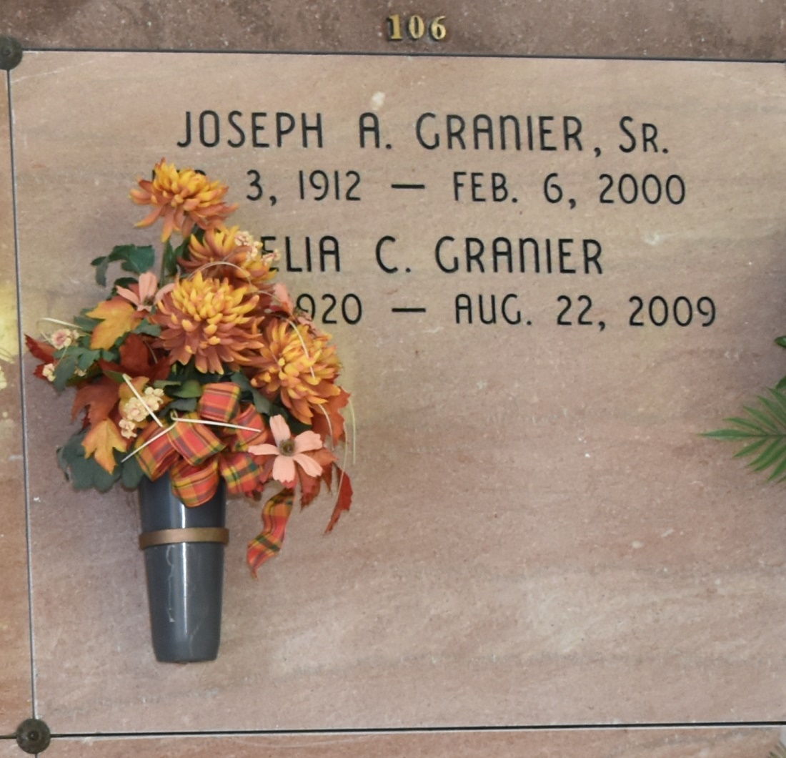

A beloved mother, grandmother, great-grandmother, sister and friend, she passed away on Saturday, Aug. 22, 2009, at her home. She was 89. She was the mother of Joseph Jr., of Baton Rouge, David and Anne, of Vacherie, Richard and Jolene, of Arvada, Colo., Juanita and Michael Quaid, of Donaldsonville, and Janet and Gerald Boza, of Tampa, Fla., grandmother of 10 and great-grandmother of eight.

Preceded in death by her husband, Joseph Granier; parents, Juanita Poche Charlet and Honore Walter Charlet; brother, Harold Charlet; and daughter-in-law, Bettye Granier.

A native of Paincourtville, she was a resident of New Orleans, St. James and Donaldsonville. Relatives and friends of the family are invited to attend a Mass of Christian Burial at St. Francis of Assisi Catholic Church, 818 W. 10th St., Donaldsonville, on Tuesday, Aug. 25, at 11 a.m. Visitation begins at 9 a.m. Entombment in Our Lady of Peace Mausoleum in Vacherie.

A special thanks to all who tended to her in her final days, including her children, neighbors, Amedysis Hospice and longtime family friend and caregiver, Eloise Jarvis. In lieu of flowers, donations may be made to St. Jude Children's Research Hospital, 501 St. Jude Place, Memphis, TN 38105 or American Cancer Society, P.O. Box 22718, Oklahoma City, OK 73123-1718.

Advocate, The (Baton Rouge, LA) - Tuesday, August 25, 2009  
Contributed by Jane Edson