Jean Paul Gravois

June 26, 1916 – January 29, 2001

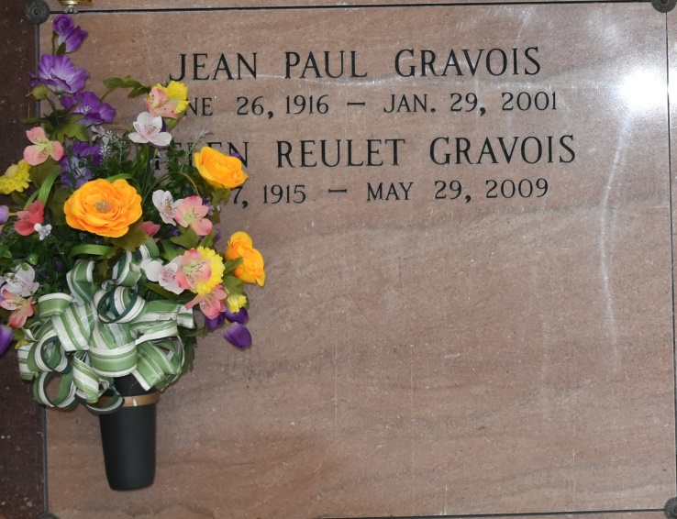

Jean Paul Gravois, a retired tractor mechanic, died Monday of natural causes at Thibodaux Regional Medical Center. He was 84. Mr. Gravois was a lifelong resident of Vacherie. He was one of the founding members of the Vacherie Volunteer Fire Department, a member of the Knights of Columbus Council No. 1514 of Vacherie and a parishioner of Our Lady of Peace Catholic Church in Vacherie. He also was a former member of the St. James Parish School Board, on which he served for 18 years. Survivors include his wife, Helen Reulet Gravois; three daughters, Lael Gravois Zeringue, Mary Gravois Bode and Margaret Gravois Perret; two sons, Colin and Jude Gravois; two brothers, Antoine and Leonard Gravois; a sister, Therese Gravois Oubre; 13 grandchildren; and nine great-grandchildren. A Mass will be said today at 10:30 a.m. at Our Lady of Peace Catholic Church in Vacherie. Visitation will begin at 7:30 a.m. Burial will be in Our Lady of Peace Mausoleum. Ourso Funeral Home in Donaldsonville handled arrangements.

Times-Picayune, The (New Orleans, LA)

Wednesday, January 31, 2001  
Contributed by Jane Edson

\*\*\*\*\*

VACHERIE - Jean Paul Gravois, 84, a native and resident of Vacherie, died Jan. 29. He was the husband of Helen Reulet Gravois and father of Lael Zeringue, Mary Bode, Margaret Perret and Colin, Jude and the late Judith and Jean Paul Gravois Jr. He was also the son of the late Ernest and Berthe Rodrigue Gravois and brother of Therese Oubre, Antoine and Leonard Gravois and the late Aline Rodrigue, Elizabeth Becnel, Marie Falgoust, Angele Steib, Claire Hirsch and Henrietta, Louis, Joseph and Augustin Gravois. He is also survived by 13 grandchildren and nine great-grandchildren. He was a founding member of Vacherie Volunteer Fire Department, former member of the St. James Parish School Board for 18 years and member of Knights of Columbus Council 1514. Services were Jan. 31 at Our Lady of Peace Catholic Church, South Vacherie, with interment at the church mausoleum.

L'Observateur, LaPlace, LA

February 4, 2001