Maggie Marie (Oubre) Gravois
September 7, 1933 – August 27, 2024

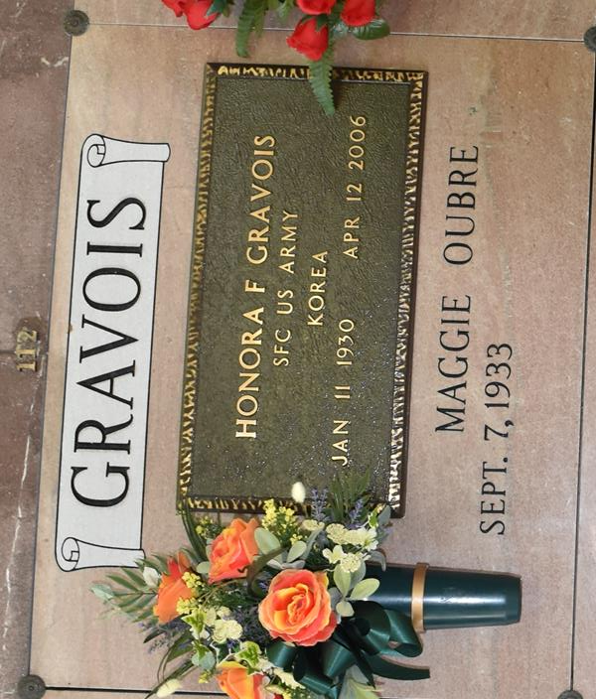

Maggie Marie Oubre Gravois, age 90 of Vacherie, LA, passed away on August 27, 2024. She was born on September 7, 1933 to Theobert Oubre and Athanasie Falgoust Oubre.
Maggie was preceded in death by her husband, Honora F. Gravois; her parents, Theobert and Athanasie Oubre; grandchildren, Jamie Gravois, Charisse Gravois and Michael Boudreaux; daughter-in-law, Judy Gravois; sisters, Eda (Harris) Webre, Cecile (Robert) Acosta, and Nola (Roderick) Brignac; brothers, Eddie (Therese) Oubre and Edwin (Grace) Oubre; and brother-in-law, Philip Granier.
She is survived by her children, Becky (Glenn) Gravois, Jake (Rachel) Gravois, Blaise (Patricia) Gravois, Grant (Bonnie) Gravois, Anna (John) Michelli, and Nora (Barry) Reulet; grandchildren, Tammy (Daniel) Templet, Kirby Gravois, Dawn Gravois Stevens, Sarah Gravois, Josh Fontenot, Aimeé (Jason) Covington, B.J. Gravois, Maci (Philip) Boudreaux, Travis (Debra) Gravois, Sadie (Corey) Fangue, Heidi (Aaron) Ertel, Kaci (Chris) Reeves, Kelci (Alex) Sotile, Jodi (Maria) Reulet and Brian (Emily) Reulet; great grandchildren, Wesley, Alex, and Aiden Templet, Glenn L. Gravois, Paige Broskey, Erin Stevens, Liam Foret, Silas and Hughlan Naquin, Mary Kathryn Covington, Faith, Noah and Benjamin Gravois, Emma and Bradley Boudreaux, Madison, Tucker, and Miles Gravois, Brody and Jaxon Fangue, Angel and Harper Ertel, Abby and Austin Reeves, Annie Sotile, Maggie, Sydney and Renee Reulet, and Harrison and Foster Reulet; sister, May Granier; and brother-in-law, Elic Gravois. Maggie's family appreciates those who cared for her at Francois Bend and Claiborne and Clarity Hospice.
Relatives and friends are invited to attend the Visitation and Funeral Mass at Our Lady of Peace Catholic Church, 13281 LA-644, Vacherie, LA on Friday, August 30, 2024. A rosary will be recited by the Catholic Daughters of America at 8:45 a.m. Visitation at the church from 8:45 a.m. to 11:00 a.m. followed by a Funeral Mass at 11:00 a.m. Interment in Our Lady of Peace Catholic Cemetery, Vacherie, LA.
Rose Lynn Funeral Home, Lutcher, Louisiana
August 30, 2024

