Pauline (Lassere) Guidry

April 5, 1927 – July 26, 2021

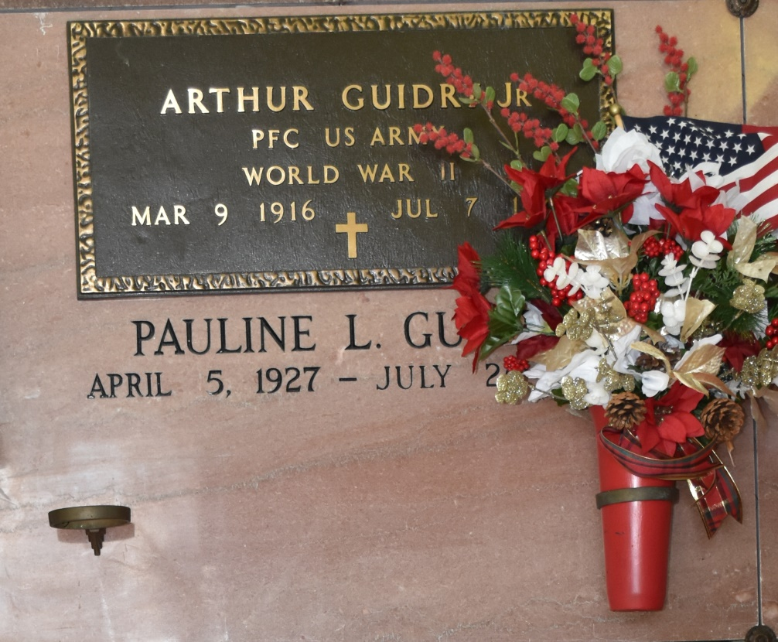

Pauline Lassere Guidry, age 94, born April 5, 1927, passed away on Monday, July 26, 2021 at 3:04pm. She was a native and resident of Vacherie, Louisiana.

She is survived by her son, Wilson J. Guidry; 2 grandsons, Quinn Guidry and wife, Trisha and Weylin Guidry and wife, Kayla; daughter-in-law, Pam Guidry-Hearon and husband, Hugh; 6 great-grandchildren, Karsyn Guidry, Kelan Guidry, Parker Guidry, Evan Guidry, Dax Guidry and Beckham Guidry.

She was preceded in death by her husband, Arthur Guidry, Jr.; son, Rudy J. Guidry; parents, Focas Lassere and Anastasia Brock Lassere; 5 brothers, Hymel Lassere, Clem Lassere, Ruffin Lassere, Eddie Lassere, and Joseph Lassere; and 3 sisters, Edith Lassere Kliebert, Marie Lassere Steib, and Rita Lassere Rodrigue.

isitation will be Saturday, July 31, 2021 from 9:00am until funeral time at Our Lady of Peace Church, Vacherie, LA. Mass of Christian Burial at 11:00am at the Church. Interment Our Lady of Peace Cemetery, Vacherie, LA. Arrangements by Ourso Funeral Home, Donaldsonville, LA.

The Guidry Family would like to thank all the caregivers: Ann Marie, Joan, Marcella, Monica, Sonia, Suzette and Tricha. Also, thanks to Ochsner Home Health nurses and the staff at Thibodaux Regional Health System.

Ourso Funeral Home, Ascension Parish, LA