Lucette M. (Lassere) Hanlin

December 17, 1924 – February 16, 2013

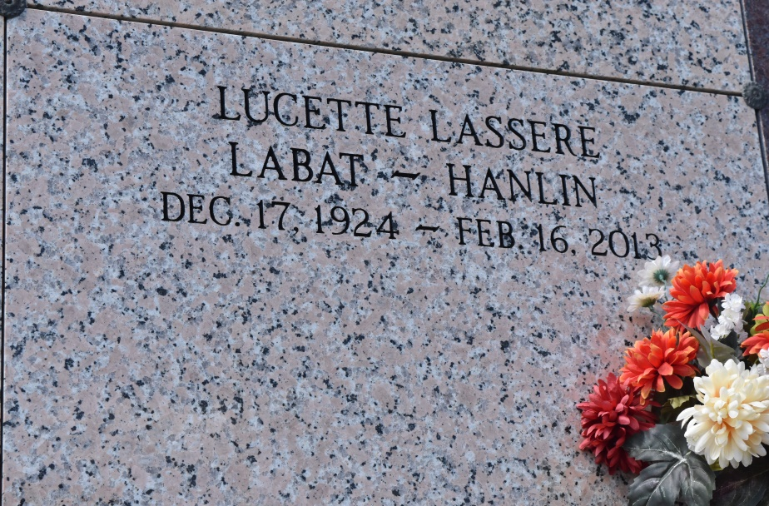

Lucette M. Lassere Hanlin, 88, died on February 16, 2013. She is survived by two sons and daughters-in-law, G. Jerome and Bonnie Labat, of Hammond, and S.Ralph and Elaine Labat of New Orleans; two grandchildren, Sean and Chris Labat; three great grandchildren; and brother, Norman Lassere and wife Madeline of Vacherie. Preceded in death by her first husband, Sidney Labat, Sr.; second husband, Carl Hanlin; parents, John and Celine Lassere; seven brothers, Oneil, Frank, Numa, Lincoln, Gasper, Malcolm, and Johnny Lassere; three sisters, Oline Brazan, Doris Jablonski, and Isabelle Simon. Visitation will be held on Wednesday, February 20, 2013 at 9:30 a.m. until Mass of Christian Burial at 11:00 a.m. at Our Lady of Peace Catholic Church in Vacherie. Interment to follow in church cemetery. Condolences can be made at [www.oursodonaldsonville.com](http://www.oursodonaldsonville.com).

Advocate, The (Baton Rouge, LA)

Monday, February 18, 2013