Aldonia (Simon) Harry

October 10, 1931 – November 12, 2012

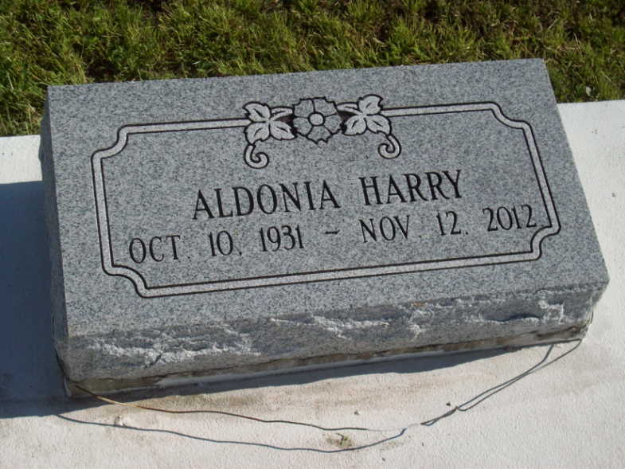

Photo by TMB

ALDONIA HARRY "DAWN" on Monday, November 12, 2012 at Thibodaux General Hospital, Thibodaux, LA. Daughter of the late Sedonia Williams and Williams Simon, Sr. Wife of Herbert Harry, Sr., Mother of Martha Harry Steib (Terrance) and the late Herbert Harry, Jr., Mother in Law of Barbara Harry, Sister of Velma Florence, Ora Lee Borne, the late Ralph Simon, Sr., Joe Simon, Williams Simon, Jr., Jessie Simon, Dennis Simon, Sr., Wilberine Chopin, and Clothilde Haydel. Also survived by 5 grandchildren, 4 great grandchildren and a host of nieces, nephews, cousins, other relatives and friends. Age 79 years. A native and resident of Vacherie, LA.

Unknown source