Florence (Armant) Harry

May 11, 1956 – August 28, 2007

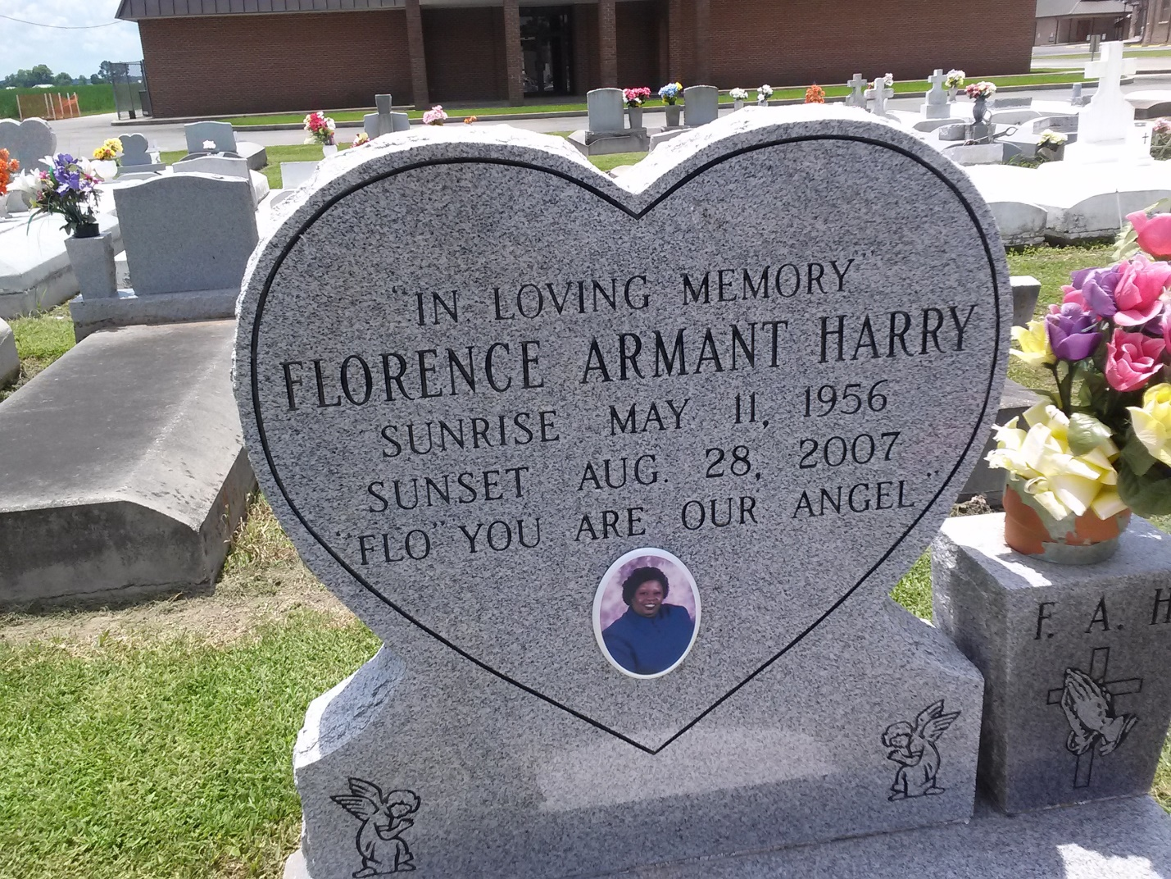

Photo by TMB

Florence Armant Harry, age 51, departed this life on Tuesday, August 28, 2007 in Thibodaux, La. Daughter of Florence Armant and the late Eliam Armant, Sr. Wife of Lionel L. Harry. Mother of Lamond and Lamont, Fallon and Tiara Harry and LaMonica Hughes. Sister of Lorenza Wright, Rose Dorsey, Joyce Joseph, Deborah Harry, Lolita and Warren Armant. Also survived by 11 Grandchildren, nieces, nephews, other relatives and friends. A native and resident of Vacherie, La.

Unknown source