John Pierre Harry Sr.

July 31, 1901 – January 17, 1996

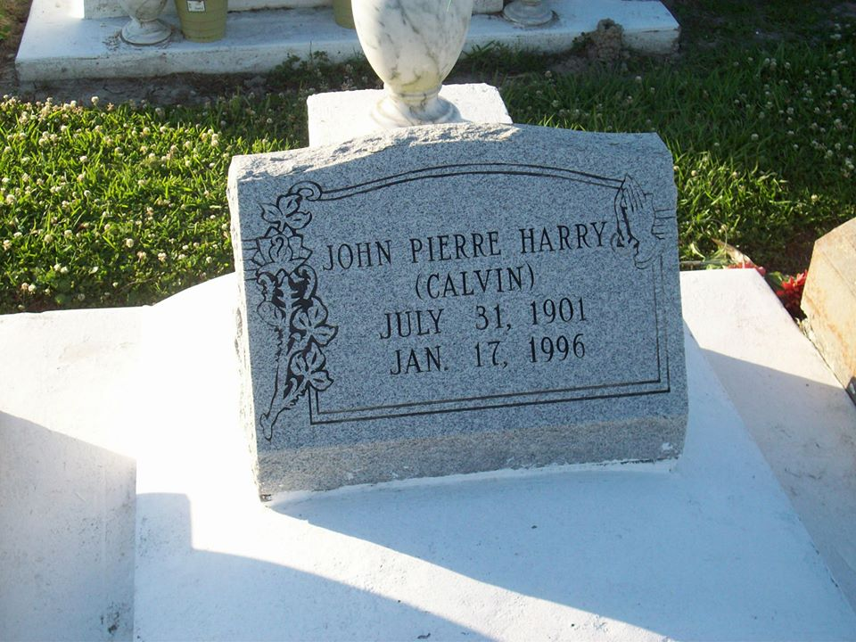

Photo by TMB

John P. Harry Sr., a retired caretaker with the Jesuit High School athletic department, died Wednesday, Jan 17, 1996 at his home. He was 95. Mr. Harry was born in Vacherie and lived in New Orleans for the past 70 years. He was the son of the late John Sr. and Josephine Osborne Harry. He was a parishioner of St. Monica Catholic Church. Survivors include three sons, John Harry Jr. of Fort Washington, Md., and Charles and Mark Harry; four daughters, Lois Harry, Dorothy James, Marguerite Estade and Mary Ricard; a brother, William Harry of Grosse Tete; a sister, Bella Anderson of Los Angeles; 22 grandchildren; 15 great-grandchildren; and a great-great-grandchild. A Mass will be said Monday at 10:30 a.m. at Our Lady of Peace Catholic Church in Vacherie. Visitation will be Monday from 8 to 8:30 a.m. at D.W. Rhodes Funeral Home, 3933 Washington Ave. Burial will be in the church cemetery.

Unknown source