Lionel Luke Harry

June 2, 1956 – April 23, 2015

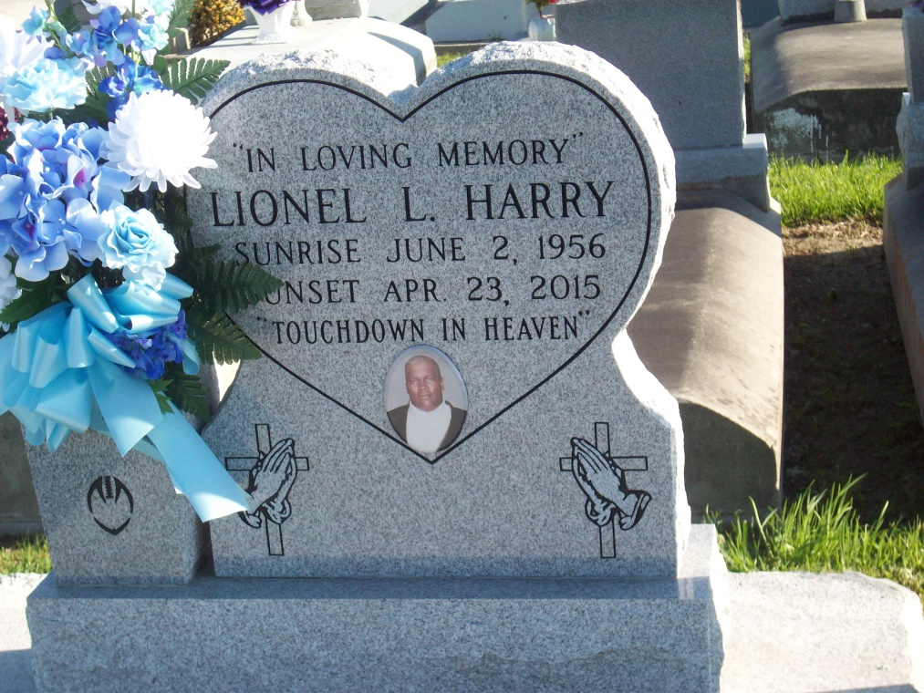

Photo by TMB

Lionel Luke Harry, Age 58, passed away on April 23, 2015, Son of Silvain & Lucille Harry, Husband of the late Florence Armant, Father of Lakesha Joseph, Lamonica Hughes, Lamont, Lamond, Fallon and Tiara Harry , Brother of Mary Jessie, Phyllis Richard, Whitney, Cassandra and Robert Harry, He is also survived by a host of grandchildren, great grandchildren, other relatives and friends. A devoted special friend Donna Bergeron, Services will be on Friday May 1, 2015 at 11:00am at Our Lady of Peace Catholic Church13281 Hwy 644 Vacherie, La 70090 Rev. Christopher Decker, Officiating Visitation at 9:00a.m. Interment in Church Cemetery, employees of Occidental Chemical Plant in Hahnville for CBI (formerly Harmony, Turner, and Shaw) are invited to attend the services. Services Entrusted to Hobson Brown Funeral Home, Garyville, La 70051. 985-535-2516

Advocate, The (Baton Rouge, LA) - Tuesday, April 28, 2015

Contributed by Jane Edson