Oralie (Dumas) Harry

January 23, 1907 – February 17, 1995

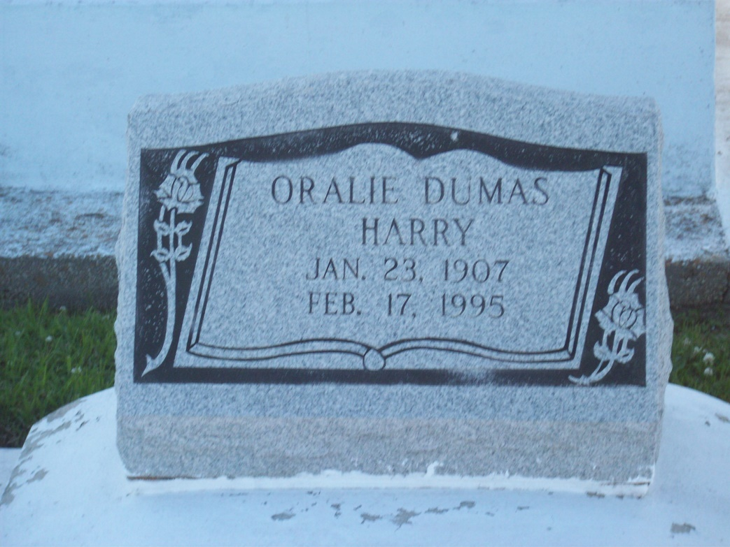

Photo by TMB

Oralie Dumas Harry, a homemaker, died Friday, Feb 17, 1995 at Touro Infirmary. She was 88. Mrs. Harry was born in Vacherie and lived in New Orleans for 70 years. She was a parishioner of St. Monica's Catholic Church. Survivors include her husband, John P. Harry Sr.; three sons, John Harry Jr. of Fort Washington, Md., and Charles and Mark Harry; five daughters, Marjorie and Lois Harry, Dorothy H. James, Marguerite H. Estade and Mary H. Ricard; a sister, Christina Oubre; 22 grandchildren; 15 great-grandchildren; and a great-great-grandchild.

Unknown source