Chandon Rico Hickerson
August 28,1998 - April 28, 2025

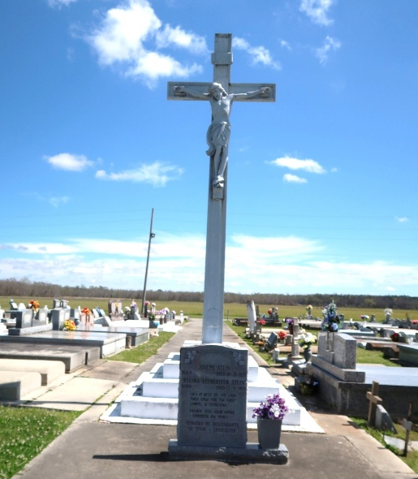

Chandon Rico Hickerson affectionately known as “Hick” and “Rico” was born on August 28, 1998, to Corliss and Emanuel Hickerson in Thibodaux, LA. Chandon was the baby of his eight siblings. To his mother, he was known as “Channy-Boo” and to his father he was always his “Babyboy”. Being the last born, he held a special place in everyone’s heart-spoiled with affection but also fiercely protected. Growing up surrounded by so much love shaped who he was- loyal, full of life, and always ready to make his family proud.
He was christened at a young age at St. Philip Catholic Church and later was baptized at New Horizon Church by Pastor Nathaniel Rapp in 2011. Chandon departed this life far too soon on Monday April 28,2025, leaving a void that can never be filled. Though his time here was cut short, Chandon’s spirit lives on through the precious memories he created and the lives he touched. He had a multitude of friends throughout his life, each one holding a special place in his heart. But in his final days, he spent most of his time with Dontaze Costly and Joseph Nelson. The bond they had created was immaculate from deep conversations to moments filled with laughter and now those moments hold more value than ever. They were more than friends - they were brothers in spirit, standing by each other through it all.
Chandon attended St. James High School and graduated in the year of 2016. He was awarded a full-ride athletic scholarship to play as a D1 athlete by East Carolina University, obtaining his Bachelor of Science degree in 2020. Chandon was awarded “the most improved defensive player”. Chandon was employed by Ferrara Fire Apparatus in Holden, La as an electrician working on fire trucks. He took pride in knowing that every wire he connected and every system he repaired played a part in saving lives. The challenge of the job, combined with purpose, gave him a deep sense of fulfillment.
On June 25, 2022, Chandon experienced one of the greatest joys of his life with Indya Tutt – as they welcomed the birth of their daughter Dream My’ Angel Hickerson. From the moment he held her in his arms, his world changed. He was filled with love, pride, and a sense of purpose unlike anything he had known before. He loved calling her “his beautiful”, “his dream pop” and his “Babygirl.”
Chandon leaves to cherish his precious memories his daughter Dream My ‘Angel Hickerson, his parents: Emanuel & Corliss Hickerson,6 Siblings: Najee’ Laurent, Sennecca Jones, Keithon Burham, Emanuel III, Ehret, and Erron Hickerson; Grandmother: Geraldine Smith; Six Aunts: Elaine Hawkins, Linda Hillard ,Patricia Ainey, Rose (Pastor Nathaniel) Rapp Sr., Carol(Larry) Alexander, Leola (Edward) Williams , & Beverely (Rev. Herman) Daniels; Two uncles: Ferdinand(Debbie) Jefferson & Whitney (Stephanie) Hickerson; Godparents Stephanie Hickerson & Ferdinand Jefferson, Four nieces, Eight nephews, One Great-Nephew, One Great-Niece, and Godchild Jayden Braxton.
Chandon is preceded in death by his Maternal grandparents: Margaret and Jentry Dumas, Paternal grandparents: Emanuel and Rosalie Hickerson, Paternal uncles: Melvin Howard and Michael Hickerson, and brother Kylan Laurent.
A Gathering of Family and Friends will be held Friday May 2,2025 from 5:00pm to 7:00pm at Treasures of Life Funeral Services, 315 E. Airline Hwy., Gramercy, LA 70052. A Celebration of Life will be held on Saturday May 3, 2025 at Highway Baptist Church, 1185 Magnolia Heights Vacherie, LA 70090 with visitation beginning for 9:00 AM until Service time at 11:00 Entombment Our Lady of Peace Cemetery.

Treasures of Life Funeral Services, 315 E. Airline Hwy., Gramercy, LA
May 1, 2025

