Diana Lee (Nickens) Hotard

September 8, 1952 – February 7, 2004

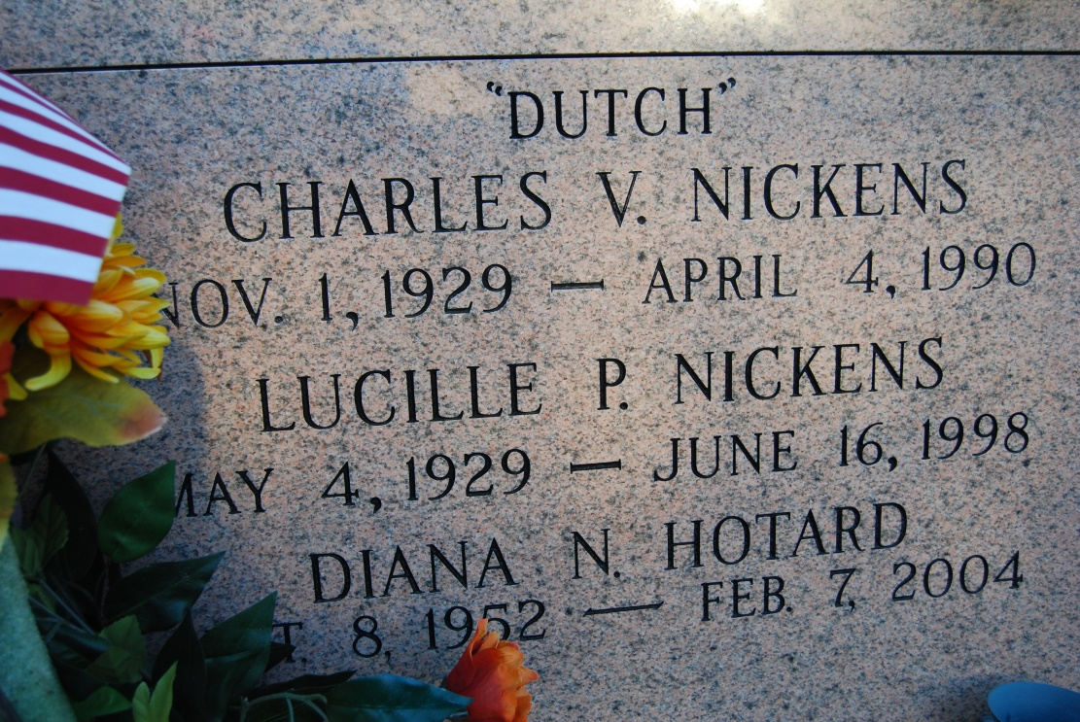

Photo by Kerry Keller

DONALDSONVILLE - Diana Lee Nickens Hotard, 51, a native of Evansville, Ind. and resident of Vacherie for 15 years, died Feb. 7. She was the wife of Roger Easton and mother of Dawn Hodges, Joey and Christopher Baudoin.  
  
She was also the daughter of the late Charles "Dutch" and Lucille Patterson Nickens, and sister of Terry Dufrene, Linda Murray and Robert Nickens.  
  
She is also survived by seven grandchildren.  
  
Services were Feb. 9 in the chapel of Ourso Funeral Home, Donaldsonville, with interment at a later date at Our Lady of Peace Cemetery, South Vacherie.

L'Observateur (La Place, LA) - Wednesday, February 11, 2004

Contributed by Jane Edson