Augustine Audrey (Steib) Howard
April 14, 1933 – August 3, 2016

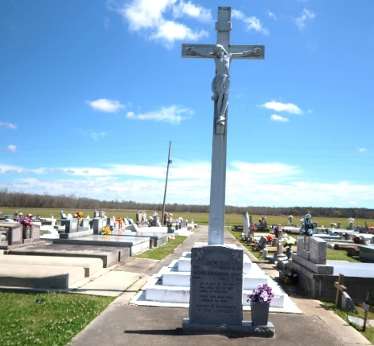

Augustine Audrey Steib Howard entered into eternal rest on Wednesday, August 3, 2016 at Passage Hospice.
Beloved wife of the late Alton M. Howard. Daughter of the late Eulan and Baldwin Steib of Vacherie, La. Beloved mother of Juanita Ford (Sherman) of Grand Prairie, Texas, Loretta and Kim Howard (Danielle) of Slidell, LA. Sister of John Steib of Oakland, CA, James Steib of Vacherie, Barbara Steib of New Orleans, LA and the late Joseph, Pierre and Vincent Steib. Grandmother of Simeon Ford, Leah Peck (Brandon) Joe Johnson IV, Gary Sr., Keirra, Peyton and Aaliyah Howard. Deceased also survived by 5 great grandchildren, 2 sister-in-law, a host of nieces, nephews, cousins, other relatives and devoted friends.
Relatives and friends are invited to attend the Mass of Christian Burial on Saturday, August 13, 2016 at Blessed Trinity Catholic Church located at 4230 S. Broad St. New Orleans, La. at 10 A.M. Visitation will begin at 8 A.M. Father Dennis Hayes officiating. Entombment will follow in Our Lady of Peace Cemetery, 13281 LA-644, Vacherie, LA.

Robinson Family Funeral Home, Belle Chasse, Louisiana

