Dennis Howard
May 7, 1953 – March 7, 2008

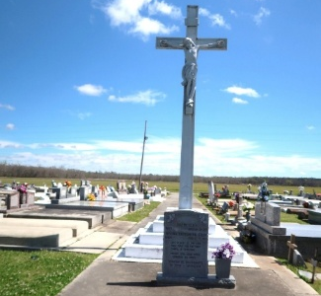

Dennis Howard departed this life on Friday, March 7, 2008. Father of Deidre and Gary Howard. Grandfather of Dijonnae, Dwayne, Derrian, and Darryon Howard. Son of Oregan "Lil Buddy" and Ethel Isom Howard, Sr. Grandson of the late John Lee and Laura James Isom, Sr., Ernest and Nettie Lewis Howard, Sr. Great grandson of the late Willie James and Isabella Smallwood. Brother of James (Sandra) Howard, Lawrence Howard, Rodney (Tammy) Howard, of Marrero, La., Arnold (Melinda) Howard of Vacherie, La., Kevin (Sonya) Howard of Edgard, La., Valerie (James) Favorite, Sr., Verlyn (Barry) Melancon of Vacherie, La., Isabelle (James) Narcisse of Westwego, La., Phyllis (Victor) Nicholas of Thibodaux, La. and the late Oregan Howard, Jr. Uncle of the late Jeanette Connerly. Brother in law of Melcom (Althea), Diamond (Shelia) and Diane of Marrero, La. Godfather of Ethen Nicholas and Purnell Garcia and a host of aunts, uncles, nieces, nephews, other relatives and friends. Age 54 years, a native of New Orleans, La. and a resident of Houston, Tx.
Relative and friends of the family, also Priest and parishioners of Our Lady of Peace Catholic Church and neighboring churches are invited to attend the Mass of Christian Burial at Our Lady of Peace Catholic Church, 13281 Highway 644, Vacherie, La., on Saturday, March 15, 2008 at 11:00a.m. Father Michael Miceli, Celebrant. Visitation from 9:00a.m. until service time at church. Interment: Our Lady of Peace Cemetery-Vacherie, La. Arrangements by Davis Mortuary Service, 230 Monroe St., Gretna, LA.

The Times-Picayune, New Orleans, Louisiana
March 14, 2008

