Lawrence Howard
August 20, 1948 - September 27, 2025

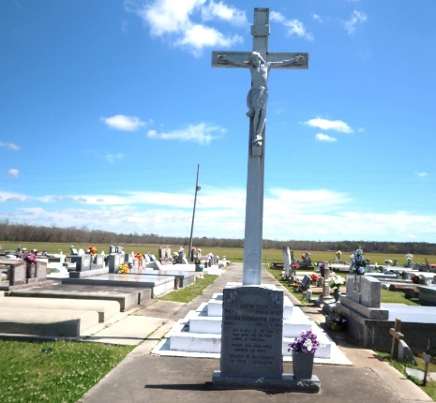

“I have fought the good fight, I have finished the race, I have kept the faith. Finally, there is laid up for me the crown of righteousness, which the Lord, the righteous Judge, will give to me on that Day, and not to me only but also to all who have loved His appearing.” 2 Timothy 4:7-8
Lawrence Howard a beloved father, brother, and friend, entered into eternal rest at the age of 77 on Saturday, September 27, 2025, at his home in Marrero, Louisiana surrounded by his loving family. A man of intelligence, strength, and unwavering determination, he lived his life to the fullest, leaving behind a legacy of perseverance, wisdom, and love. As preordained by God, Lawrence Howard graced this world on August 20, 1948, as the beloved son of Oregan and Ethel Howard, Sr. He was the first son of nine offspring born into this union. He was baptized in the Catholic faith. Lawrence became a proud honor graduate of West Jefferson High School, Marrero, Louisiana. He graduated at the top of his class setting the foundation for a lifetime of learning and accomplishment. He continued his education and became a proud graduate of Southern University A& M College Baton Rouge, Louisiana, where he embraced the power of education, often reflecting on the truth that “Education is the most powerful weapon which you can use to change the world.” His love for learning followed him throughout life, and he could often be found in the aisles of Barnes & Noble, enjoying books and expanding his knowledge. On November 9, 1972 Lawrence was blessed with the birth of a daughter, Dionne Shonte’ Howard, whom he loved and cared for. They often had healthy debates while drinking coffee and spending quality time together. He encouraged her love of books and instilled in her a perspective grounded in life experiences, encouraging her to see the world as it truly is “Reality over Fantasy”. He dedicated more than 27 years as a plant operator at American Cyanamid in Waggaman, Louisiana, where his work ethic and reliability earned him the admiration of his colleagues. After surviving a stroke, he refused to be defeated. He remained independent, determined, and committed to living life with grace, courage, and joy. His humor, wisdom, and strength of spirit left a lasting imprint on everyone blessed to know him. Pondering his heavenly departure and treasuring his legacy is his loving daughter Dionne Howard; three sisters Valerie (James) Favorite, Phyllis Nicholas, and Verlyn Melancon; four brothers James, Arnold (Melinda), Rodney and Kevin Howard; Godson Farrel Isom; and a host of nieces, nephews, and other family and friends. Family members awaiting Lawrence’s arrival; his loving parents Oregan Howard, Sr. and Ethel Isom Howard; grandparents John Lee and Laura Isom, Sr. and Ernest and Nettie Howard, Sr.; great grandmother, Isabella Smallwood; brothers Dennis Howard and Oregan Howard, Jr.; sister Isabelle Howard Narcisse; niece Jeanette Conerly; nephew Ross Jackson; and great nephew Chase Favorite. Lawrence Howard received a call with an offer he couldn’t refuse. The assignment came with a huge sign-on bonus, a reunion with family and friends he had not seen in a long time. His new mission took him to a beautiful place where he is socializing and reading many books as much as his heart desires. Laughter and love are guaranteed. A Mass of Christian Burial will be held at St. Joseph the Worker Catholic Church, 455 Ames Blvd., Marrero, LA, 70072 on Friday, October 10, 2025, at 10:00 a.m. Reverend Sidney Speaks, III, officiating. Visitation begins at 8:00 a.m., Recitation of the Rosary at 8:45 a.m. Interment Our Lady of Peace Catholic Church Cemetery, 13281 LA-644, Vacherie, LA. 70090.

Treasures of Life Funeral Services, Gramercy, Louisiana
October 14, 2025

