Allen Paul Hymel
April 12, 1937 - August 12, 2025

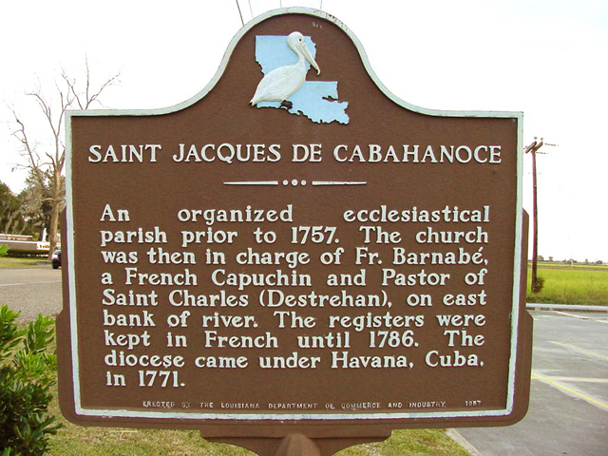

Coach Allen Paul Hymel, 88, entered eternal rest peacefully on Tuesday, August 12, 2025 surrounded by his family who he greatly loved and adored.
He was born on April 12, 1937 and was baptized in his hometown of Vacherie. As a devoted Catholic and parishioner of St. Philip, he regularly attended mass and faithfully lit candles to memorialize others.
Allen graduated from St. James High School in 1955, Southwestern Louisiana Institute (ULL) in 1959, and later earned his Master’s degree from LSU. His love for our country led him to serve in the Army National Guard and was honorably discharged after 3 years of service with badges awarded in Marksman and Sharpshooter. For thirty years, he was a math teacher and coach of football and track in St. John the Baptist and St. James Parish schools, as well as a member of the Louisiana High School Coaches Association. In 2022, “Coach” was inducted into the St. James High School Hall of Fame. He was a charter member and treasurer of the St. Philip Hunting Club and a Knights of Columbus 3rd Degree Knight. In his free time, he enjoyed gardening, being a crawfish fisherman and farmer, and hunting. Allen enjoyed watching and attending LSU sporting events, rarely missing LSU games.
Family was the center of his life. He loved Cajun dancing with his wife and “Honey” of 67 years, Rose Marie Gravois Hymel. “Daddy” treasured guiding his children, Elaine (Spuddy) Faucheux, Dennis (Lisa) Hymel, Sr., Donna Viator, and Christie (Marshall) Crooks. “Paw Paw” spoiled his ten grandchildren Lindsay (Nick) Cambre, Erin (Michael) Becnel, Dennis (Traci) Hymel, Jr., Heather Faucheux, Mandy (Carson) Allen, Jessica (Mason) Case, Erik and Kelsie Viator, Allen Paul and Reecie Crooks and adored his ten great-grandchildren Cruz, Kash, and Slade Cambre, Malcolm and Joel Becnel, Genivieve and Martin Hymel, Graham and Oliver Allen, and Vivian Case. He shared his faith with his brothers and in-laws Gerard (Clothilde) Hymel and Nolan (Eleanor) Hymel, the late Frank Hymel (Alice Hymel), Linda (the late Bean) Chenier, FJ (the late Iris) Loup, Rosalie (the late Carol) Hymel, Aubrey (Mary Ellen) Gravois, Eugene (Marie) Gravois, Lynn (the late Ernest) Gravois, Chip (Aimee) Simon, and Maria (the late Dean) Gravois. “Uncle Allen” was cherished by all of his nieces and nephews.
Allen is preceded in death by parents, Francis and Valerie Hymel, Sr; son-in-law Mark Douglas Viator, and in-laws, Antoine and Florence Gravois.
Visitation will be at St. Philip Catholic Church in Vacherie on Tuesday, August 19, 2025 from 6:00-9:00 p.m. and Wednesday, August 20, 2025 from 9:00-10:45 a.m. followed by a Funeral Mass at 11:00 a.m. A Christian Burial will follow at Our Lady of Peace Cemetery. Pallbearers will be Dennis Hymel, Jr., Michael Becnel, Nick Cambre, Carson Allen, Mason Case, Erik Viator, Allen Paul Crooks, Cruz Cambre, and Rydell Malancon. Honorary pallbearers include Charles Hymel, great grandsons, and former players and members of the St. Philip Hunting Club.
In lieu of flowers, mass intentions are preferred. Allen held onto these words throughout his life and spoke them in his final days. “I hold it true, whate’er befall; I feel it, when I sorrow most; “tis better to have loved and lost then never to have loved at all.” He will be missed tremendously by all.

Rose Lynn Funeral Home, Lutcher, Louisiana
August 19, 2025

