Grace (Lemoine) Hymel
August 6, 1934 – April 9, 2025

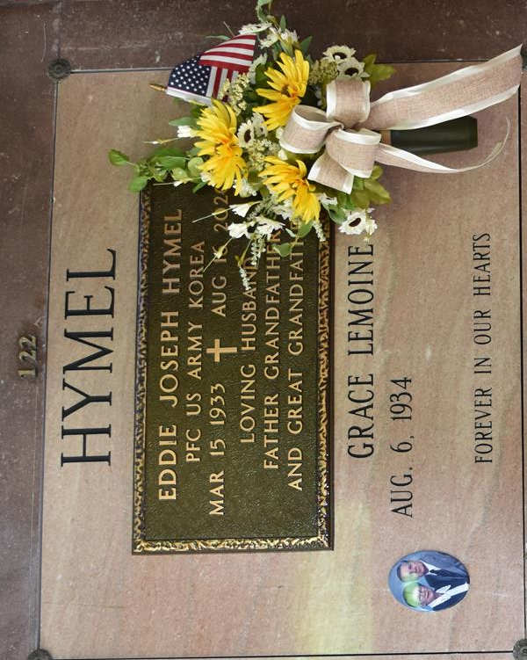

Grace Lemoine Hymel transitioned into eternal rest on Wednesday, April 9, 2025 at the age of 90. Born August 6, 1934, she was a native of Lucy, LA and a lifelong resident of Vacherie, LA.
Family and friends will be received at Our Lady of Peace Catholic Church, 13281 LA-644, Vacherie, LA, on Wednesday, April 16, 2025, from 8:30 a.m. to 12:00 p.m. A rosary will begin at 9:00 a.m. A Mass of Christian Burial will begin at 12:00 p.m. with burial following at Our Lady of Peace Cemetery, Vacherie, LA.
Grace was a loving wife, mother, grandmother, and great-grandmother. She is survived by her 4 children, Brenda Gravois (Alan), Janel Berger (Don), Danny Hymel (Snoopy) and Chad Hymel (April). She is also survived by 8 grandchildren, Brad Gravois (Tiffany), Ryan Gravois , Casey Ledet, Nick Berger (Terese), Aaron Hymel (Sydney), Cody Hymel (Lauren), Riley and Ellie Hymel; and 10 great-grandchildren, Hannah, Hali and Parker, Christopher and William, Grayson, Emersyn and Julia, Norah and Maggie; sister Rosalie Waguespack (Charles); brothers Roland and Earl Lemoine (Joan); sisters-in-law Ruby Lemoine, Carlyn Kliebert, Janet Ponson, and Teen and Janice Hymel; brothers-in-law James Becnel and Jack Bourgeois.
Grace is preceded in death by her husband of 64 years, Eddie “Boobie” Hymel; daughter, Sharon H. Ledet; parents, Louis Nicholas Lemoine and Agnes Madere Lemoine; and sister Hilda Bordelon, brothers Melvin, Stephen and Ross Lemoine, sisters-in-law Audrey H. Becnel, Sylvia H. Bourgeois, Jane H. Rivere, Melba and Fannie Lemoine, brothers-in-law Warren, Kelsey, and Herman “T-Boy” Hymel, Carroll Ponson, Sr., Louis Bordelon and A.J. Kliebert, Jr.
Grace was a homemaker, who enjoyed cooking and making her famous pralines and pecan fudge. She was an excellent cook who loved preparing meals for family gatherings. She was physically active enjoying her daily walks and bike riding. She was also a devoted CDA Charter member and a committed adorer at the adoration chapel.
Those who knew Grace will remember her for her infectious smile, her deep-rooted faith in Jesus and unwavering commitment to spreading love and kindness to everyone she met.
The family would like to extend their appreciation to her loving and dedicated caregivers and Heart of Hospice.
In lieu of flowers, donations can be made to Arc Angels’ Treasures in Vacherie, LA.

Rose Lynn Funeral Home, Lutcher, Louisiana
April 16, 2025

