Joseph C. Isom

April 16, 1938 – February 17, 2012

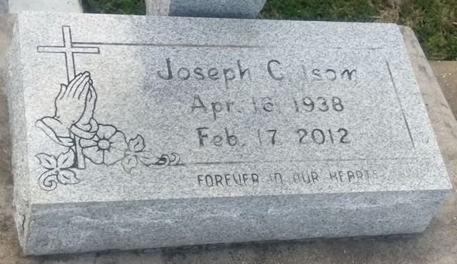

Photo by TMB

A retired welder with Avondale Industries (Northrop Grumman), he died Friday, Feb. 17, 2012, at his residence in Vacherie. He was 73, a native and resident of Vacherie. Survived by his wife, Mildred Winston Isom, of Thibodaux; three sisters and spouse, Ethel I. Howard, of Marrero, Josephine I. Kennedy, of New Orleans, and Lottie and Peter Mitchell, of St. James; two sisters-in-law, Faye B. Isom, of Pomona, Calif., and and Evelyn D. Isom, of Vacherie; four stepchildren and spouses, Michael and Nanette Jones, Saleina Jones Steward and companion Same Ellis, and Denise and Carroll Adams, all of Thibodaux, Jeffery and Kenya Jones, of Holbrook, Ariz; other-in-law, Elena Q. Winston, of Thibodaux; 13 stepgrandchildren, 6 brothers-in-law, 6 sisters-in-law, and a host of nieces, nephews, other relatives and friends. Preceded in death by his parents, Laura and John Isom Sr.; a sister, Alice I. Steib; three brothers, John Jr., Willie and Noris Isom; father-in-law, John Winston Sr.; four brothers-in-law and a sister-in-law. Special thanks to his nephew, Peter Mitchell and a devoted cousin, Thomas Bartholomew.

Unknown source