Effie (Steib) Jackson

September 1, 1927 – March 7, 2015

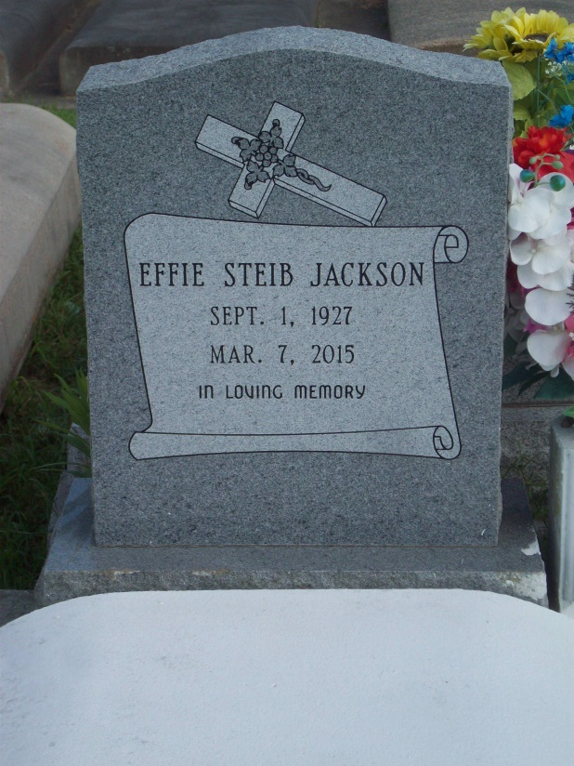

Photo by TMB

Effie S. Jackson on Saturday, March 7, 2015 at her home in Killona, LA.

Daughter of the late Nellie Holmes and Murphy Steib. Wife of the late Murphy Jackson, Sr. Mother of Nellie Alexander (Carter, Sr.), Murphy Jackson, Jr. (Diane), Joycelyn LeBeauf (Roland), Ralph Jackson, Sr., Charlene Jackson, Vanderbill "Doley" Jackson (Vanessa), Michelle Cox (Bryant), the late Latricia and Haywood Jackson. Sister of the late Virginia Kirkling, Norphy, Wilson, Estmond, Edmond, Murphy, Jr. and Edward Steib. Sister in law of Georgiana Stipe. Also survived by one devoted cousin Octavia Guss, one devoted friend Leona Raymond, 20 grandchildren, 35 great grandchildren, 1 great great grandchild and a host of nieces, nephews, other relatives and friends. Age 87 years. A native of Vacherie, LA and resident of Killona, LA.

Unknown source