Jean (Lorio) James
June 28, 1940 – October 9, 2025

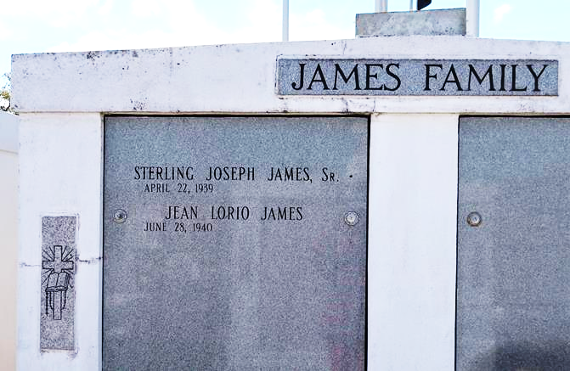

JEAN LORIO JAMES was born on June 28, 1940, in Killona, Louisiana, to the late Anita and Ford Lorio. She peacefully entered eternal rest on October 9, 2025, at her home in Vacherie, surrounded by love.
A native of Killona and a resident of Vacherie for 65 years, Jean was a devoted parishioner of Our Lady of Peace Catholic Church and will be deeply missed by all who knew her. Jean is survived by her beloved children: daughters Agnes (Huey) Harris and Anjanette (Ryan) Wicks of Viera, FL; sons Michell (Yulinda) James and Sterling (Charlene) James Jr. She also leaves behind cherished grandchildren: La Shell (Joseph) Christy, Sterling James III, MiKhell James Sr., Trey Wicks, Cameron Wicks, Lauryn Harris, and Eden James; and great-grandchildren: MiKhell James Jr., Brynn James, Micah James, and Braelyn James. Her godchildren include Terrell Wilson, Patrick Wheelock, Jeanine White, Joycelyn LeBeauf, Barbara White, Irvin Mitchel Jr., and Michele Seymore. Jean is also survived by her loving sisters: Diana Wheelock, Laverne Lorio, Sandra (Vercy) Scott, and Denise (Stacy) Francis, along with a host of nieces, nephews, cousins, and dear friends.
She was preceded in death by her husband Sterling James Sr., her parents, Anita Woods Lorio and Ford Lorio; parents-in-law, Agnes and Heedley James; sister Anita (Harold) White; brother Chandler Lorio, sister-in-law Mathilda (Howard) Jones; and brother-in-law Joseph Ivan (Celeste) (Eva) James.
A woman of unwavering faith, Jean was a dedicated member of Our Lady of Peace Catholic Church, where she served as a Eucharistic Minister and was a Charter Member of the Catholic Daughters of the Americas Court Notre de la Paix #2316. Jean graduated from Straight University School of Business in New Orleans, Louisiana. Professionally, she was a valued and loyal employee of St. James/Regions Bank, where she worked for more than 30 years.
Affectionately known as Mommy and Maw Maw, Jean was known for her sweet, welcoming spirit and joyful heart. She loved helping others in need, offering words of peace and wisdom, and inspiring those around her to live with faith and purpose. Jean enjoyed cooking, sewing, cheering on the Saints and LSU Tigers, and spending precious time with her children, sisters, grandchildren, great-grandchildren and friends. Her home was always filled with laughter, love, and heartfelt conversations about the importance of education, hard work, enjoying life and keeping God first. Jean’s life was a beautiful reflection of faith, family, and love. Her memory will forever remain a treasured blessing to all who were fortunate to know her.
Funeral Services: Relatives and friends are invited to attend the Mass of Christian Burial at Our Lady of Peace Catholic Church, 13281 Hwy 644, Vacherie, LA, on Thursday, October 16, 2025, at 10:30 a.m. Visitation will begin at 8:30 a.m., followed by the Praying of the Rosary. Interment will follow at Our Lady of Peace Cemetery. Following the services, all are invited to a repast at the Church Hall.

Treasures of Life Funeral Services, Gramercy, LA
October 19, 2025

