Marie Celeste (Dumas) James
February 1, 1940 – May 16, 2023

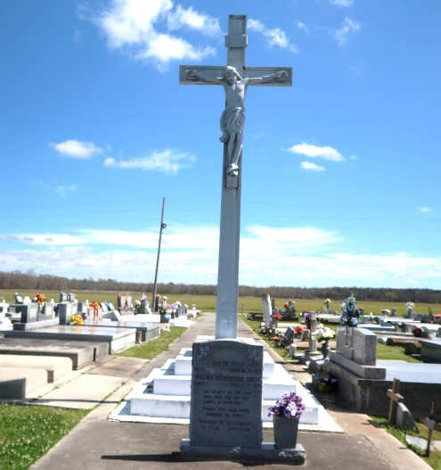

Marie Celeste Dumas James, lovingly known as Mom, Maw Maw, C, Cel, Les, & Auntie Celeste, was born February 1, 1940 as the youngest daughter of 14 to the union of the late Rose Osborne & Paul Dumas of Vacherie, LA. She gained her angel wings on May 16, 2023. She was baptized at & attended Our Lady Of Peace Catholic Church. She was reunited in Heaven with her husband Joseph Ivan James; her parents Rose & Paul Dumas; her siblings Wilborine (Hilton Sr.) Steib, Victorine (William I) Simon, MaryJane (Alcee II) Freeman, Agnes (Standford) Wooden, Paul (Nelva & Madelyn), Harry, John, Hayward (Florence), Whitney I (Leona), Russell (Rose), & Anthony; her sister-in-law Mithilda (Howard) Jones; her grandson Trey Kirton; her step-daughter Paulette Smith; and Godson Dwight Jackson.
She was educated at Shell Mound Elementary & was a graduate of Magnolia Senior High School Class of 1958. She was a member of the Good Children Society, T'Chapeau, and a former member of Ladies of Auxiliary.
Celeste was a loyal caregiver of many throughout her career & life. She worked as a nanny, a private duty sitter for local families, a housekeeper for Our Lady of Peace Catholic Church, a CNA at West St. James Parish Hospital, and at Thibodaux State School where she was promoted to Supervisor. She was a life-long resident of her beloved community of Vacherie until her late 70's when she lived with her eldest daughter in LaPlace, LA as her health slowly declined.
Celeste was the devoted wife of the late Joseph Ivan James for 44 years. Together they were blessed to have a blended family of 13 Children. She leaves behind cherished memories with her six children Patrice Dumas, Rosalyn (Michael) Mitchell, April Dumas (Jesse), Troy (Connie) Dumas, Sunniva (Paul), & Cristy James (Rob); six step-daughters Clairrita (Leonard) Raphael, Joelle Seymore, Acquanette (Reginald) Foussell, Fredricka (Harry) Calloway, Christine (Norris) Washington, & Eva (Howard) Irving; as well as her 14 grandchildren Deshaun (Terri) Dumas, Andy (LaShonnya) Harry Jr., Madesyn & Michael Mitchell Jr., Jordy (TyKesha) Dumas, Mallory (Kennedy) Foster, Sa'Megan Saul, Jasmine (Helumuth) Rousseve, Ariel Dumas, Troy Dumas, Jr., Natalie (Cory) & Rachel Carter, Gabriella (Justin) & Cristopher Russ; and an additional 10 bonus grandchildren through her husband Joseph: Dustin Raphael, Angelica (Brandon) Kennard, Michele (Chris) Gordon, NeKisha Seymore; Chaz Roussell, Erica (Daryl) Thomas, Danielle Calloway, Nicole & Brookes Washington, & Michael Irving. She is also remembered by her 17 great-grandchildren Deshaun Jr., Dean, & Dylan Dumas; Ariel Williams, Ziyia Dumas-Harry, Aiden & Ashten Harry; Journee & Karson Dumas, Dillion & Lauryn Grosvenor; Harlie & Kyhia Foster; Joshua Wylie II, Paige & Shem Yah'El Rouseeve; and Janson Mouton. An additional 4 bonus great-grandchildren through her husband Joseph: Gavin McNeil; Eliza Kennard; and Kendal & Khole' Thomas. She also leaves to cherish her memory her sister-in-laws Deloros (Harry) Dumas , Joyce (John) Dumas, her brother-in-law Sterling (Jean) James I, her Godchild Cynthia Hines, and a plethora of neices, nephews, cousins, other relatives and friends.
Mom/Maw Maw had a youthful & sweet spirit!! She was playful with her children, grandchildren, and great-grandchildren making jokes, laughing, dancing, encouraging them, and baking tea cakes. Celeste means heavenly and that is what she truly was. She will be dearly missed and forever loved.
Relatives and friends of the family are invited to attend a Funeral Mass of Christian Burial at Our Lady of Peace Catholic Church, 13281 Hwy 644, Vacherie, LA on Tuesday, May 30, 2023 at 11:00AM. Visitation will begin at 8:00AM. Interment: Our Lady of Peace Cemetery, Vacherie, LA.

D. W. Rhodes Funeral Home, New Orleans, Louisiana

