Sterling Joseph James
April 22, 1939 – August 12, 2024

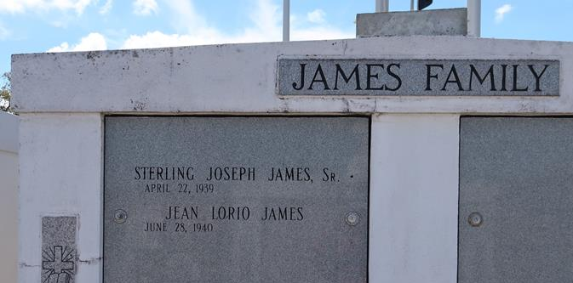

STERLING JOSEPH JAMES was born on April 22, 1939, in Vacherie, LA, to the late Agnes and Heedley James. He peacefully departed this life on August 12, 2024, at the age of 85, at his home in Vacherie.
Sterling was a native and resident of Vacherie. He was baptized at and attended Our Lady of Peace Catholic Church and will be deeply missed by all who knew him. Sterling James Sr is survived by his wife, Jean Lorio James of Killona, LA; daughters, Agnes (Huey) Harris and Anjanette (Ryan) Wicks of Viera, FL; sons, Michell (Yulinda) James and Sterling (Charlene) James Jr. He is also survived by his grandchildren: La Shell (Joseph) Christy, Sterling James III, MiKhell James SR, Trey Wicks, Cameron Wicks, Lauryn Harris, Eden James, and great-grandchildren: MiKhell James Jr and Brynn James, Micah James, as well as godchildren: Adeline Williams, Desiree Isom, Jeanine White, and Patrick Wheelock. Additionally, he is survived by his sisters-in-law: Diana Wheelock, Laverne Lorio, Sandra (Vercy) Scott, Denise (Stacy) Francis, and a host of nieces, nephews, cousins, and friends.
Sterling was a faithful member of Our Lady of Peace Catholic Church and a retired employee of Avondale Shipyard, having worked there for 43 years. Sterling was a professional bass guitar musician and loved playing in the 50s with many well-known artists, other talented family musicians, and friends. He was a member of the Good Children Benevolent Society and T'Chapeau, served as an usher at Our Lady of Peace Catholic Church, and was known as a dedicated gardener. You could always hear him whistling in his garden, as this was something he loved to do. Affectionately known as Daddy/Paw Paw, Sterling had a youthful and joyous spirit. He cherished spending time in his garden and sharing his produce with the community, shrimp trawling, hunting, and fishing. He had a playful demeanor with his children, grandchildren, and great-grandchildren, often engaging in jokes and laughter and imparting words of encouragement about the importance of education, hard work, and keeping God first at all times. Sterling will be deeply missed, and his memory will be forever cherished.
Relatives and friends of the family are invited to attend a Funeral Mass of Christian Burial at Our Lady of Peace Catholic Church, located at 13281 Hwy. 644, Vacherie, LA on Saturday, August 17, 2024, at 10:00 a.m. Visitation will commence for 8:00 a.m., followed by the Praying of the Rosary for 8:50 a.m. The Funeral Mass will begin for 10:00 a.m. with Fr. Mike O’Rourke officiating. Entombment will take place at Our Lady of Peace Cemetery.

Treasures of Life Funeral Services, Gramercy, Louisiana
August 16, 2024

