Harold Joseph Jessie
October 24, 1943 - August 22, 2024

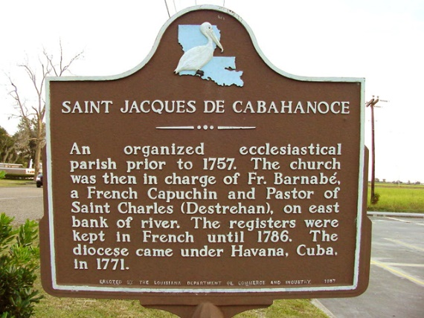

Harold “Speedo” “Casper” Joseph Jessie, at the age of 80, departed this life on Thursday, August 22, 2024, at Thibodaux Regional surrounded by loved ones. He was a native and lifelong resident of Vacherie, LA. Harold was born October 24, 1943 to the late Lloyd Jessie and Elodie Steib Jessie.
Harold was a painter at Avondale Shipyard for 38 years. His nickname “Speedo” came from a family dog named Speedo that used to follow him everywhere. The nickname “Casper” stems from him having a white ’55 Chevy. When he would arrive people would say, ‘Here comes Casper the ghost’. He enjoyed the outdoors and could be seen walking, sitting under the carport, or doing his yard projects. Painting and drawing were his passions--those artistic skills were passed down to his children, a granddaughter and great-granddaughter. Harold was known to keep his vehicles in pristine condition; his 1996 Chevrolet truck is still on the road. There was no straying from his routine, his family could tell you what he was doing based on the time of the day. His famous quotes were “whatever”, “It don’t matter”, and “I don’t care who don’t like it.”
Harold is survived by his devoted wife, Mary Evelyn Harry Jessie of 56 years, his three children- Donavon (Rashondra) Jessie, Lori Favorite, and Philip Jessie; seven grandchildren- Reanne (Raihaan) Alexander Sr., Kevin Lucien, Zaria Favorite, Nania Jessie, Aniya Jessie, Khaden Jessie, and Judaea Durant-Cannedy; four great-grandchildren- Ta’Rhea Dapremont, Raihaan Alexander Jr., Ra’Jai Alexander, and Jayven Lucien; three siblings- Jimmy (Florence) Jessie, Johnny Jessie, and Elnora Narcisse; four godchildren- Lena Keller, Paul Harry, Sonya Lumar, and Dane Clark Sr.; devoted friend- Carter Lumar; and a host of nieces and nephews.
He is preceded in death by his parents Lloyd and Elodie Jessie; four siblings- Rose Mary Harry, Elodie Dumas, Rose Annie Woods, and Eleroy Jessie.
A Mass of Christian Burial honoring his life and legacy will be held on Saturday, August 31, 2024 at Our Lady of Peace Catholic Church, 13281 La-644, Vacherie, La 70090. Visitation begins for 9am followed by Mass for 11am, Fr. Mike O’Rourke celebrant. Entombment to follow at church cemetery.

Treasures of Life Funeral Services, Gramercy, Louisiana
August 31, 2024

