Hattie Mae Rankins (Neylon) Jones

November 24, 1945 – September 24, 2016

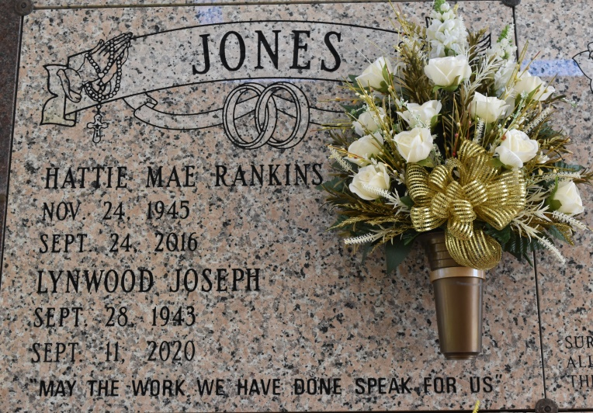

Hattie Mae Rankins Jones, a retired Direct Support Professional departed this life at her home in Vacherie, LA. On Saturday, September 24th, 2016 at 11:30 AM. Hattie leaves to cherish her memory a husband, Lynwood Joseph Jones, six children: Otis R. Jones (Helen) of Katy, TX., Terrilyn Jones Lumar (Wilfred) of Vacherie, LA., De'Shane Jones Birdis (Reginal) of Darrow, LA., Shemika Jones, Nakia Jones Jackson of Vacherie, LA., and Sharmaine Jones Bergeron (Darian) of Darrow, LA., 12 grandchildren: Brittany Lumar, Mason Johnson, Ariel Birdis, Jare Birdis, Chaz'Min Jackson, Niran Jackson, Jace' Celestin, Darianna Bergeron, Darian Bergeron Jr., Darinae Bergeron, Desean Jones and Delanie Jones, and one great granddaughter: Jour'nee Smith; 2 sisters: Diane Anderson of Thibodaux, LA. and Pearlie Williams (Walter) of Missouri City, TX. Mrs. Jones is preceded in death by her parents, Percy Neylon Sr. and Mildred Jackson Neylon and 2 brothers: George and Percy Neylon. Visitation to be held at The Baloney Funeral Home located at 1905 West Airline Highway, LaPlace, LA. 70068 on Friday, September 30th, 2016 from 2:00PM-5:00PM. Funeral Services will be held at Our Lady of Peace Church located at 13281 LA-644, Vacherie, LA. 70090, on Saturday, October 1st, 2016 at 11:00 AM. Viewing will be from: 8:30AM-10:30AM, Celebration of life will begin at 10:30AM-11:00AM followed by a Mass of Christian Burial beginning at 11:00AM. Interment will be at Our Lady of Peace Cemetery. Funeral arrangements entrusted to The Baloney Funeral Home located at 1905 West Airline Highway, LaPlace, LA. 70068 (985) 224-8460. Condolences may be offered at [www.baloneyfuneralhome.com.](http://www.baloneyfuneralhome.com/)

The New Orleans Advocate (LA)

Sep. 29 to Oct. 6, 2016