Norman Joseph Jones

December 10, 1945 – May 25, 2016

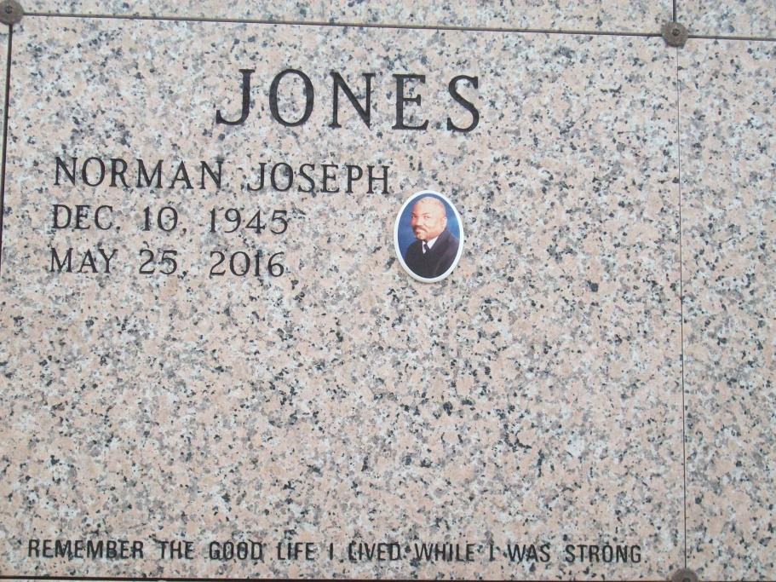

Photo by TMB

Norman Joseph Jones aka "Sluggo" entered into eternal rest on Wednesday, May 25, 2016. A native of Vacherie, Louisiana to the late Herman Joseph Jones and Elnora Lemieux Jones. Norman acknowledged his faith and belief in Jesus Christ at an early age. He was a faithful member of Holy Innocence Catholic Church in Brooklyn, New York.  
 Norman is survived by his son Darryl Jones, two sisters Jean E. Bradley of Brooklyn, New York, Caroline Rapp (Samuel) of New Orleans and two brothers Lynwood Jones (Hattie Mae) of Vacherie, Louisiana, Perry Duskin (Barbara) of New Orleans, Louisiana. Special Friend Ruth McQueen of Brooklyn, NY. He is also survived by an aunt Beaulah St. Junior of New Orleans, Louisiana. As well as a host of nephews and nieces.  
 Norman was preceded in death by his parents Herman Joseph Jones, Elnora Lemieux Jones, brother Donald Ray Jones and sister Yvonne Simpson.  
 Funeral services will be held at Our Lady of Peace Catholic Church, 13281 LA 644, Vacherie, LA. on Saturday, June 4, 2016 at 10:00 a.m. Interment will be at Our Lady of Peace Catholic Church Cemetery, Vacherie, LA.

Unknown source