Charles Mark Keller, Sr.

May 28, 1924 – January 29, 2017

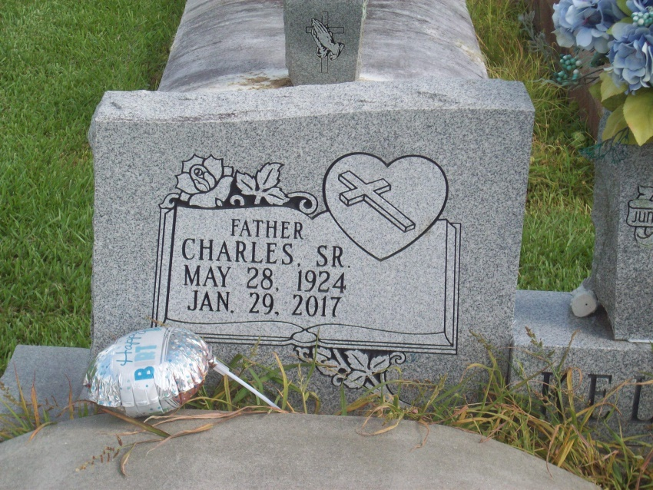

Photo by TMB

Charles Keller, Sr., 92 of Vacherie, LA passed away peacefully with his family by his side on Sunday, January 29, 2017 at his daughter's home in Baton Rouge, LA. Born in Geismar, LA on May 28, 1924, Charles was a WWII U.S. Navy veteran and retired from Avondale Shipyards. He was widower of Septemia Gibson Keller with whom he shared 64 years of marriage. He is survived by his five children, Theresa Keller, Peggy Keller-Kelly, Maxine Keller-Spurlock(Alphonse), Troy Keller(Pamela) and Lisa Keller; 17 grandchildren and 11 great grandchildren; four sisters; Susie St. Juniors, Dorothy Roussel (Wilbert), Margaret Williams and Willie Mae Smith; one brother Larry Keller, Sr. (Gloria). Also predeceased by children; Linda, Kenneth Sr., Gayle, Charles Jr., and Ricky Sr.; parents Morris and Catherine Morris Keller; brothers, Clarence Byrd and Morris Keller, Jr., and sister Shirley Keller-Daughtry. The family extends sincere thanks to the staff of VA Home Based Primary Care Hospital at Home, particularly, Dr. Yolanda O'Rourke, Sheila Thomas, RN and Kimberly Lockett, pharmacist. Visitation Saturday February 4, 2017 at Our Lady of Peace Catholic Church, 13281 LA Highway 644, Vacherie, LA, at 9:00am followed by a Mass of Christian Burial at 11:00am, Father Reuben Dykes, Celebrant. Interment Our Lady of Peace Catholic Church Cemetery. Treasures of Life-Center for Life Funeral Services. 315 E. Airline Hwy, Gramercy, LA, have been entrusted with his final care. 225-258-4039.

Times-Picayune, The (New Orleans, LA)

Wednesday, February 1, 2017